**Template for Submission of Experiment 28**

**Digital Electronics with Altera**

**Part II: The Practical Part**

|  |
| --- |
| **Important:** Marking of all coursework is anonymous. Do not include your name, student ID number, group number, email or any other personal information in your report or in the name of the file submitted via VITAL. A penalty will be applied to submissions that do not meet this requirement. |

* **Important**: When taking snapshots from the screen (for schematic or simulation), **for each and every snapshot** please **FIRST** use **PrintScreen** under MS Windows, or CMD+SHIFT+3 or **Screenshot** under macOS (which shows the entire desktop including time and date and helps to identify this as uniquely your work) **AND THEN ALSO** use the **Snipping** tool (MS Windows) or **Screenshot** tool (macOS) to show only the relevant part of your design or simulation. If the entire desktop is not visible in your first screenshot, the associated ‘focussed’ screenshot will be ignored and the corresponding section of your report will receive a mark of zero.
* **Throughout this assignment, please insert your initials and underscore, at the beginning of all saved filenames. This should be readable from the title of the relevant window. This instruction is implied below with “YI” for “your initials”.** If this format is not followed, corresponding sections will receive a mark of zero.
* Including screenshots of other people’s work is considered as academic malpractice and will be penalised in accordance with the University Codes of Practice.
* All **code** should be included as **text** and **not** screenshots.

1. **The compilation result of the design in Section 2.3 [3 Marks]**

**Screenshot (PrintScreen or equivalent):**

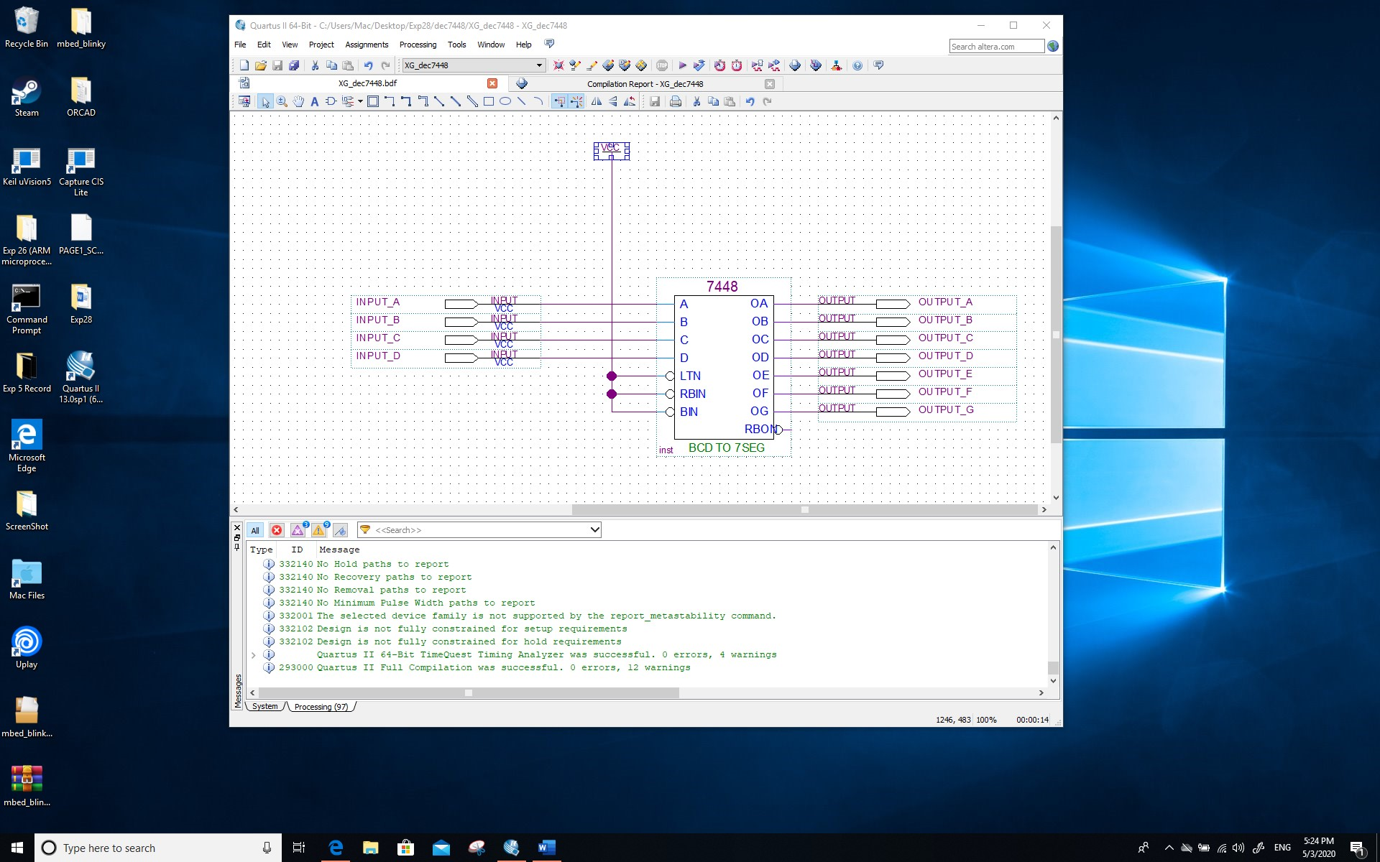

**Screenshot (Snipping tool or equivalent):**

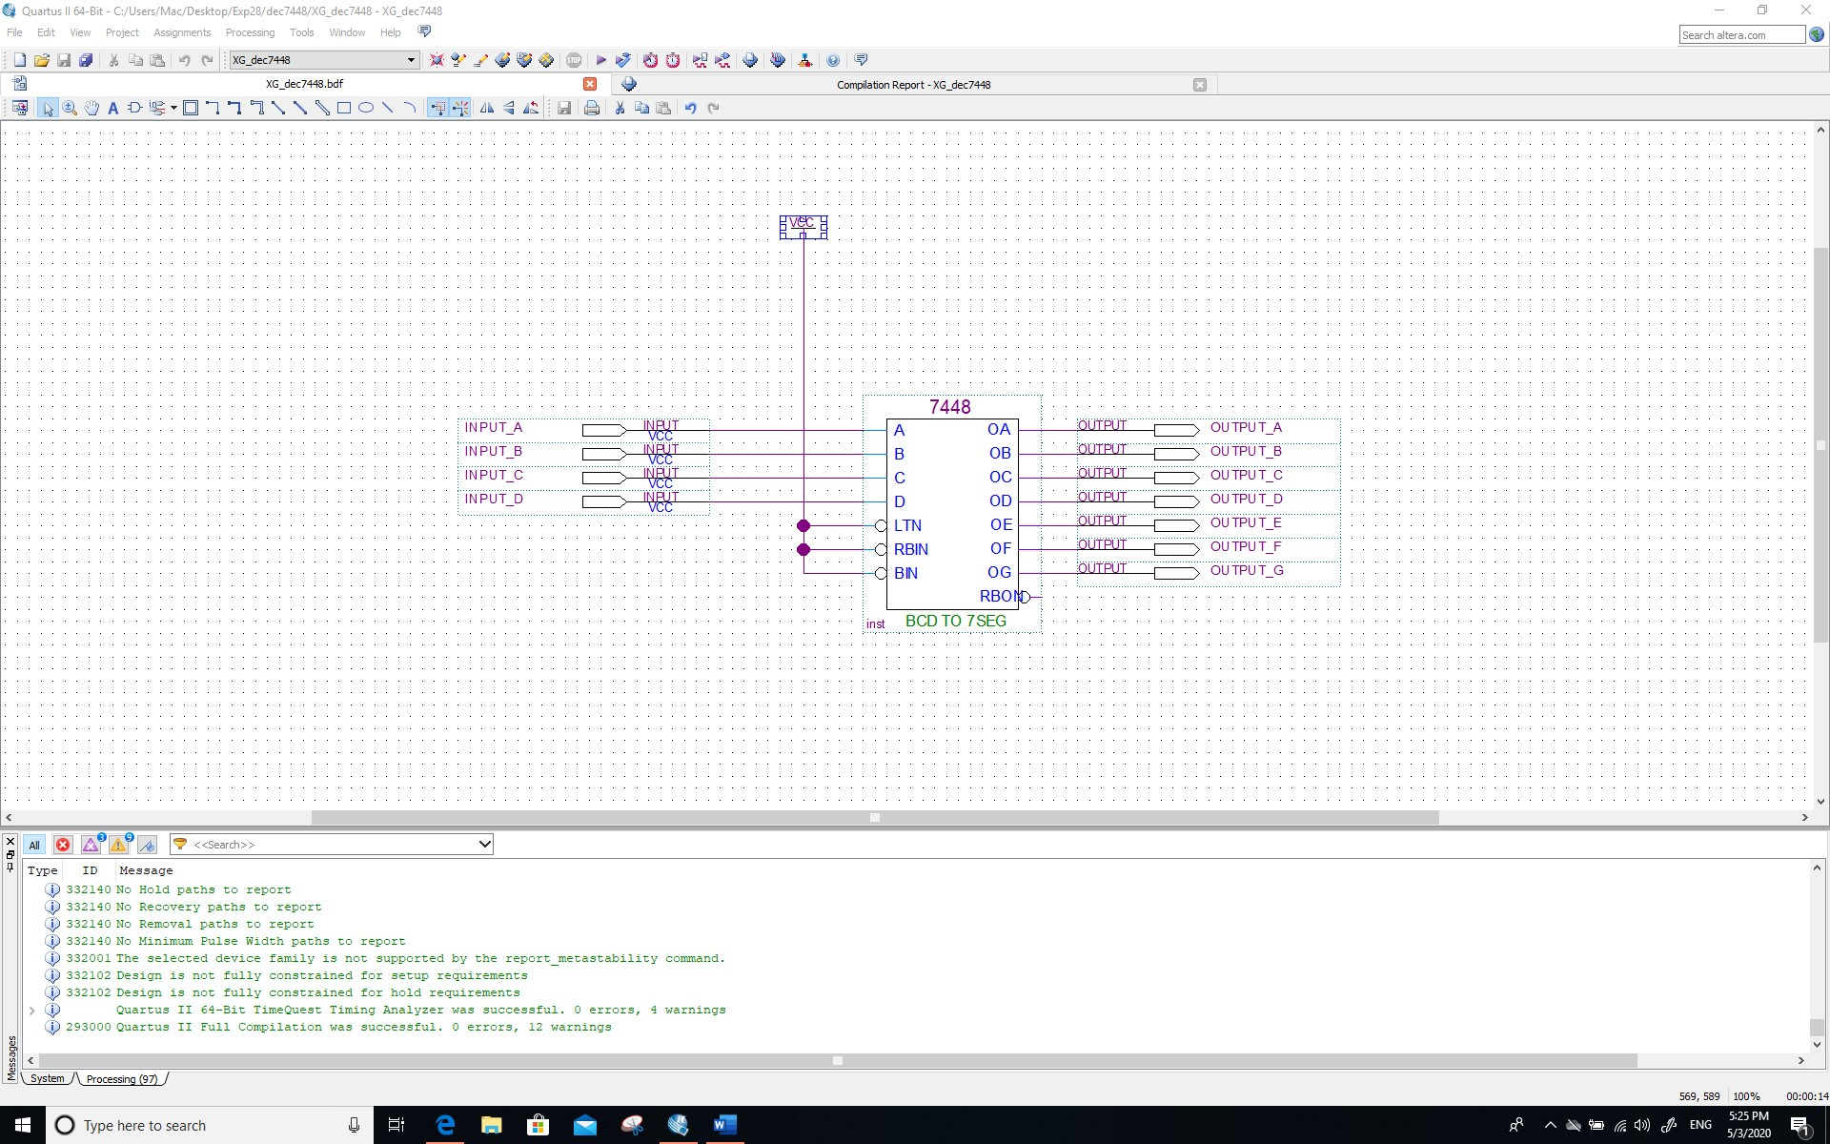

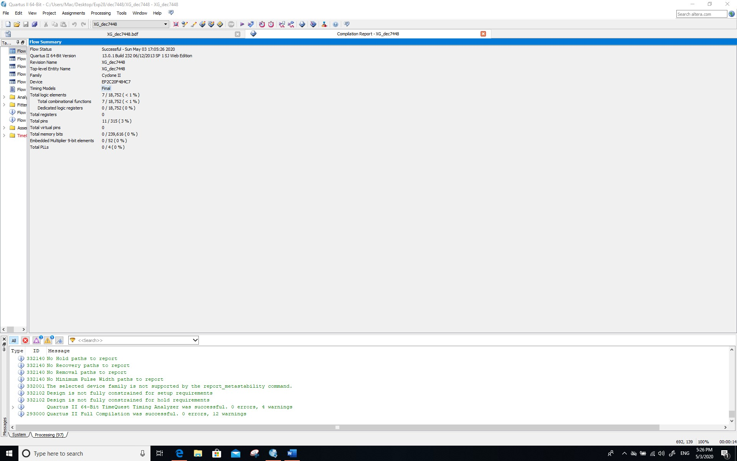

**Comment/Explanation:**

**The 7448 is connected successfully in the schematic.**

1. **The output simulation waveform in Section 2.4 [3 Marks]**

**Screenshot (PrintScreen or equivalent):**

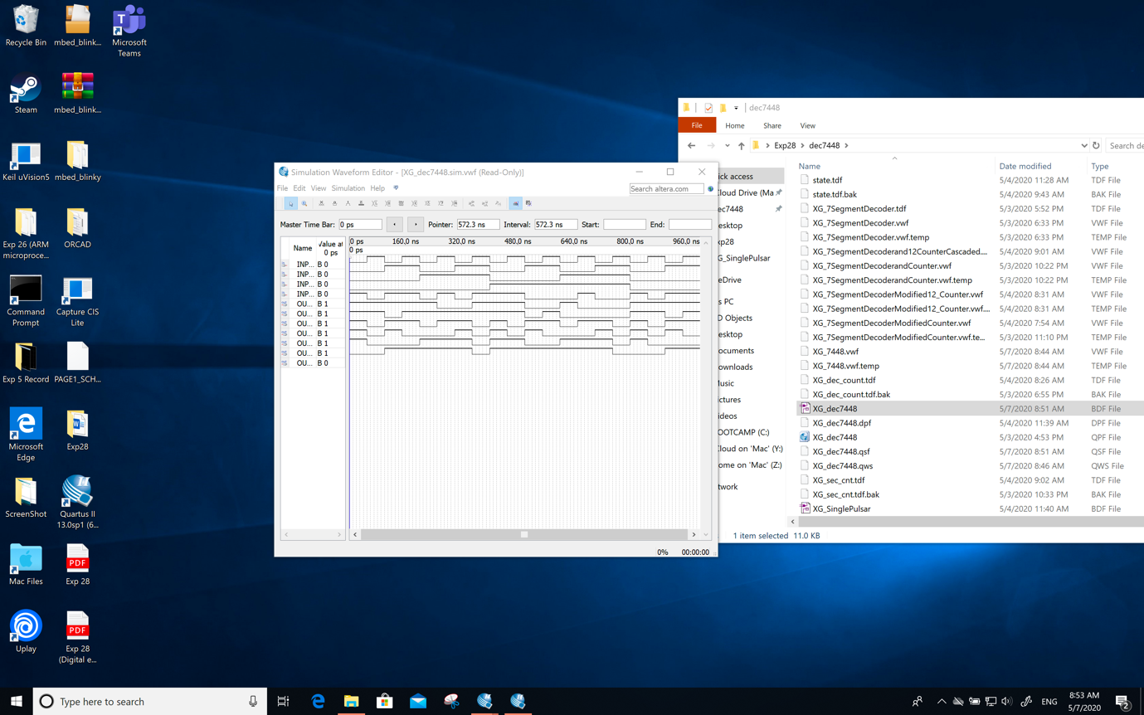

**Screenshot (Snipping tool or equivalent):**

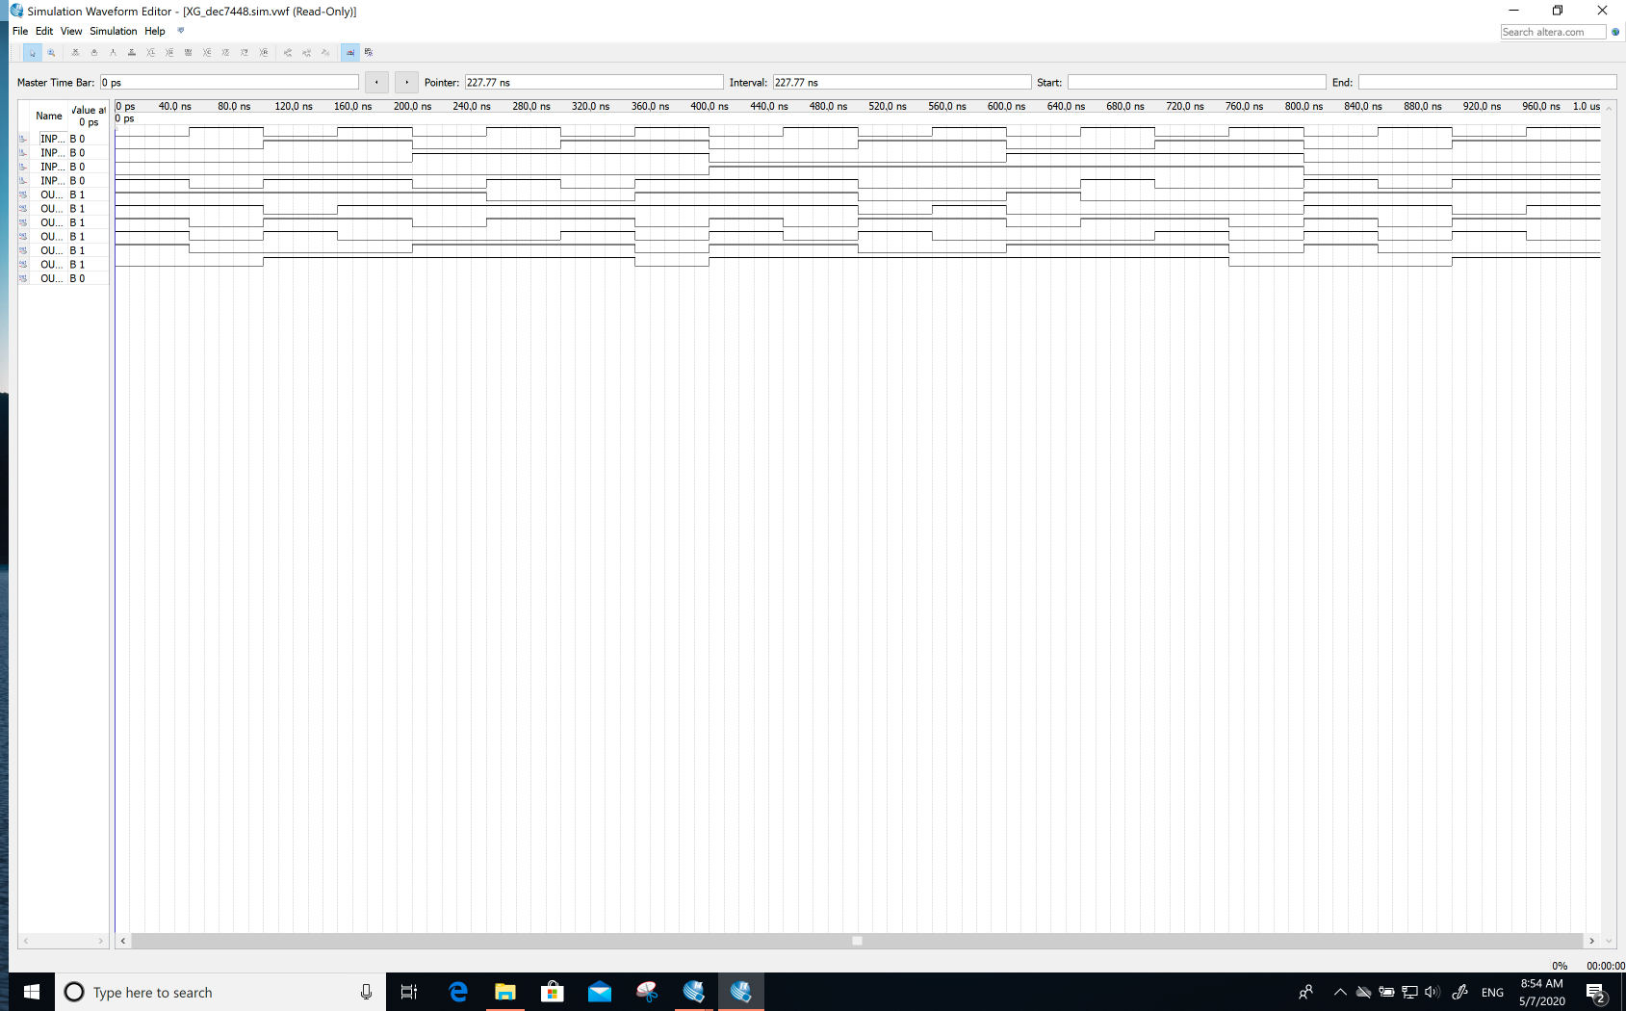

**Comment/Explanation – *including your brief answer to the question ** in Section 4.2 of the Supporting material document*:**

**The counter began to increase, but the 7-segement could not be displayed normally, because it is necessary to increase the NOT gate, because the high potential of the tube does not light up, and the low point is on.**

1. **The schematic *YI_7SegmentDecoder.bdf* of Section 2.5 [4 Marks]**

**Screenshot (PrintScreen or equivalent):**

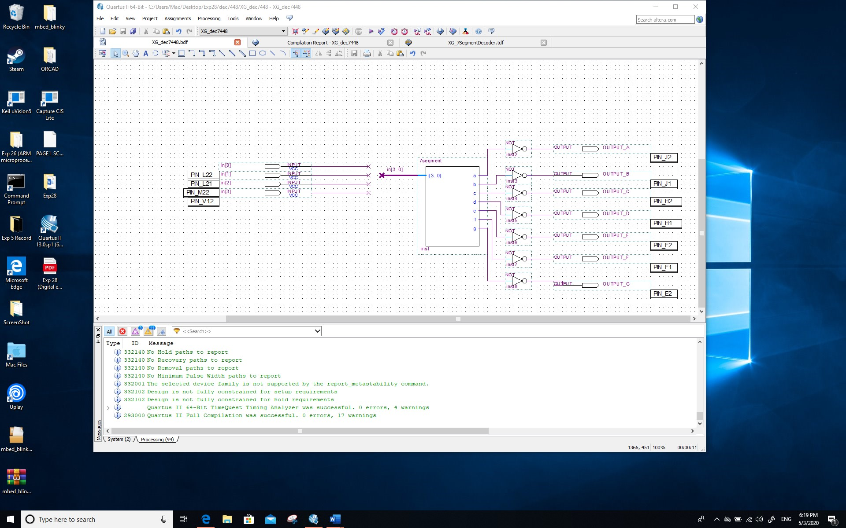

**Screenshot (Snipping tool or equivalent):**

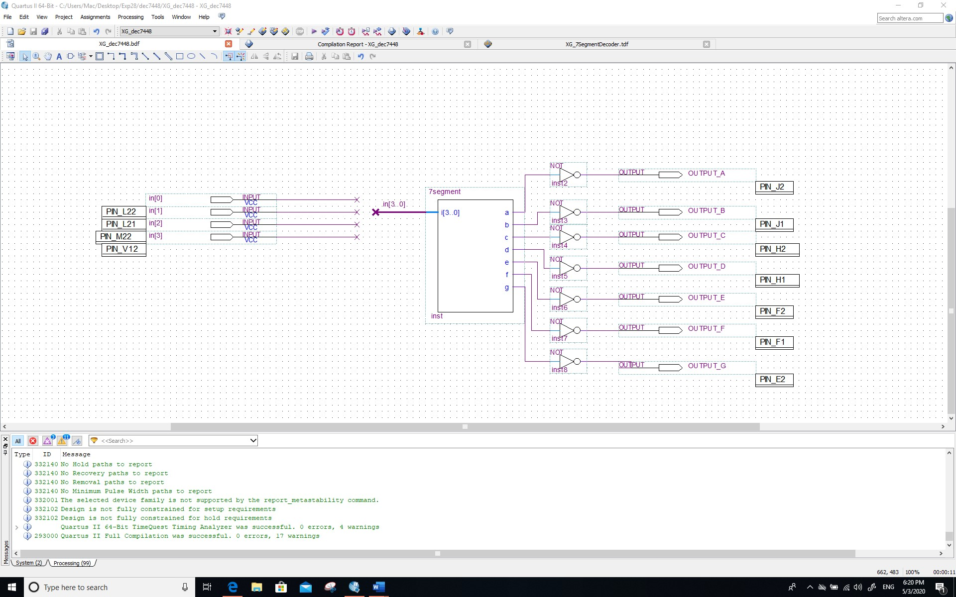

**Comment/Explanation:**

**Customize 7-segment with code, as shown in the figure, the pin is also assigned. In the actual test, pin is needed to complete the experiment.**

1. **The simulation waveform of Section 2.6 [4 Marks]**

**Screenshot (PrintScreen or equivalent):**

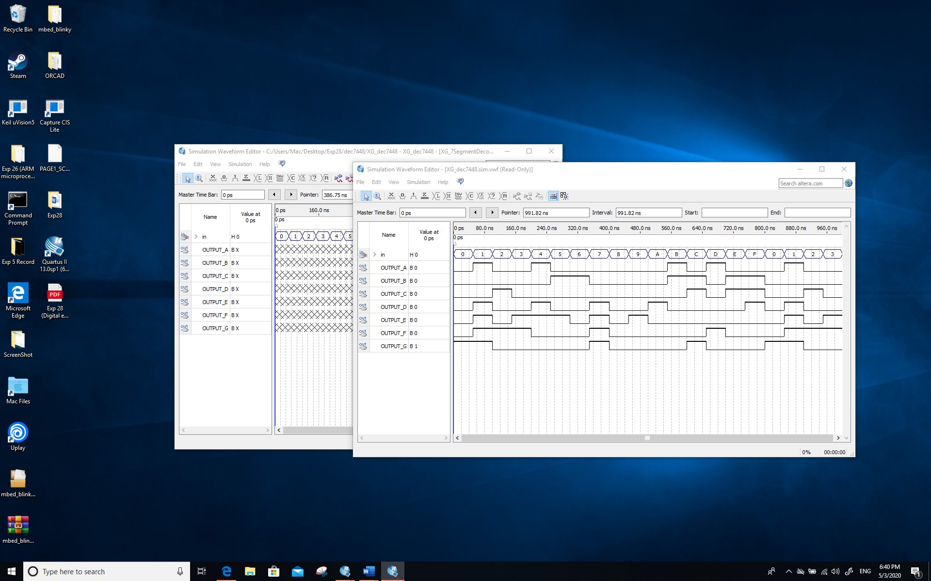

**Screenshot (Snipping tool or equivalent):**

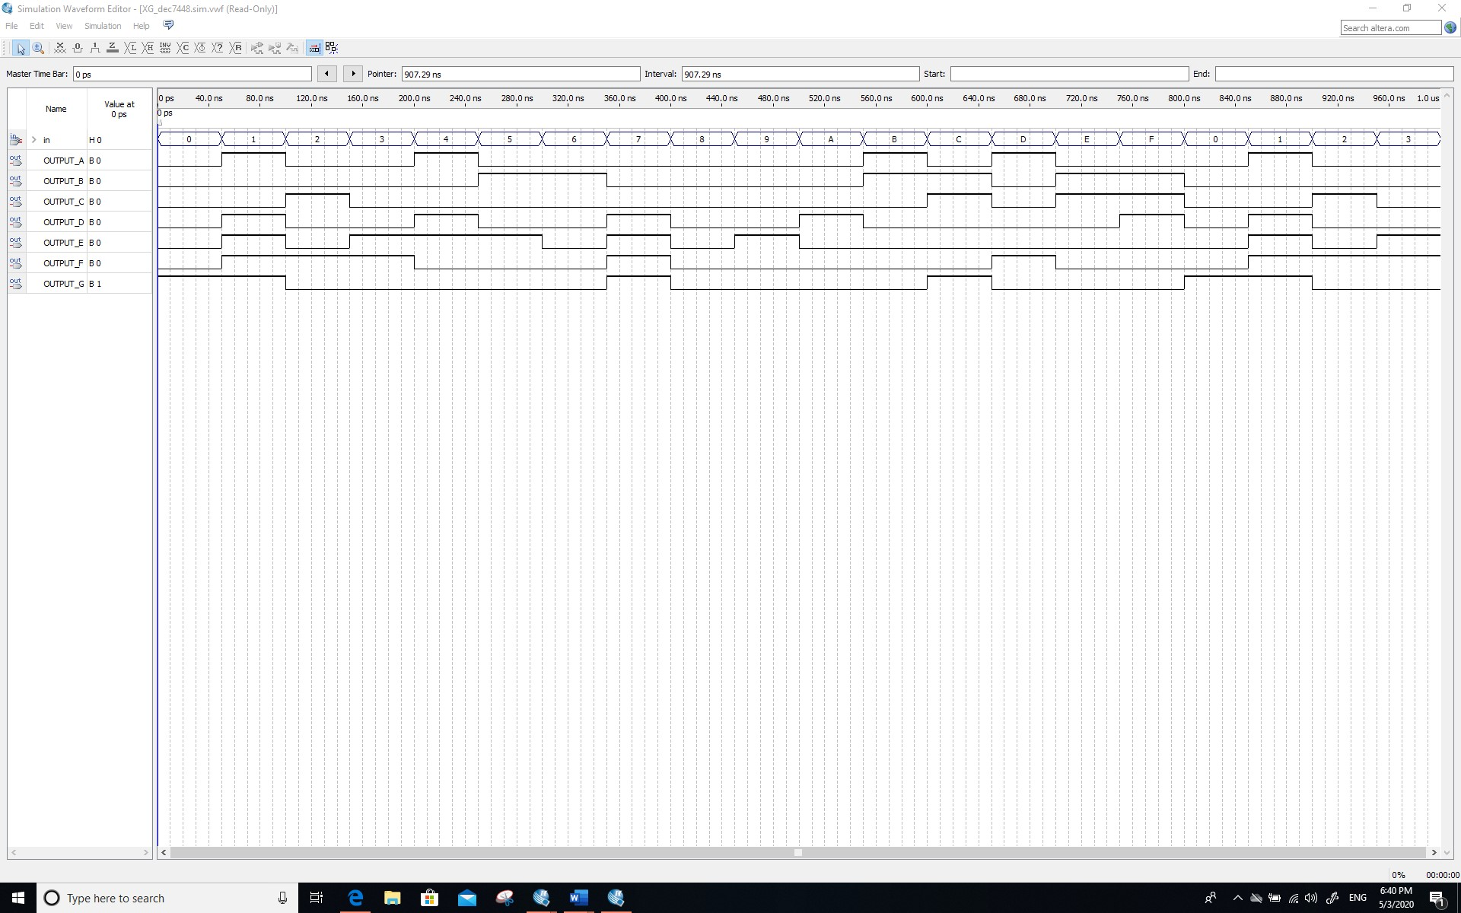

**Comment/Explanation:**

**It can be verified from the figure that the decoder works normally, and the input signal has been converted into the signal that can be displayed by the digital display tube from the 0 to the F.**

1. **The schematic *YI_dec_counter.bdf* of Section ‎3.1 [4 Marks]**

**Screenshot (PrintScreen or equivalent):**

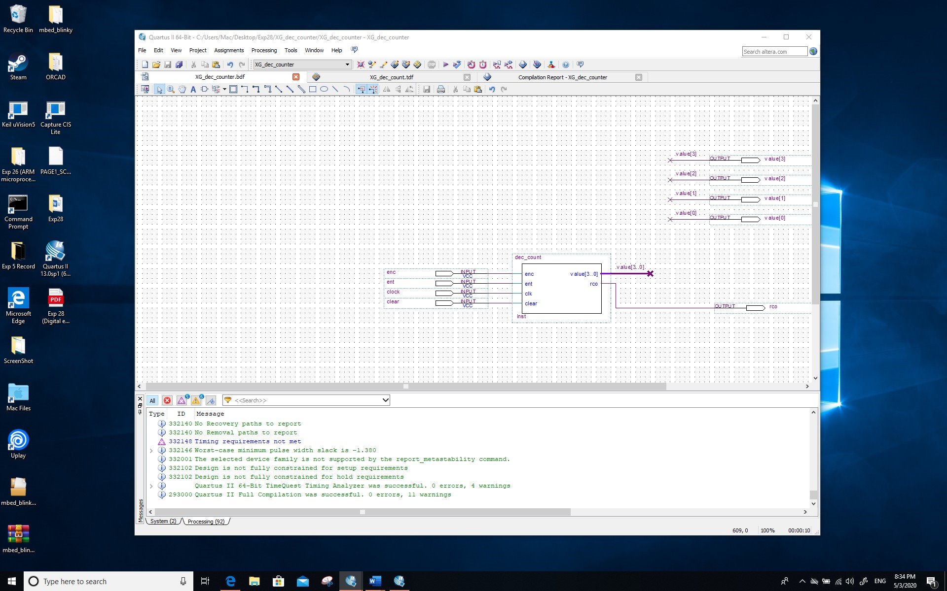

**Screenshot (Snipping tool or equivalent):**

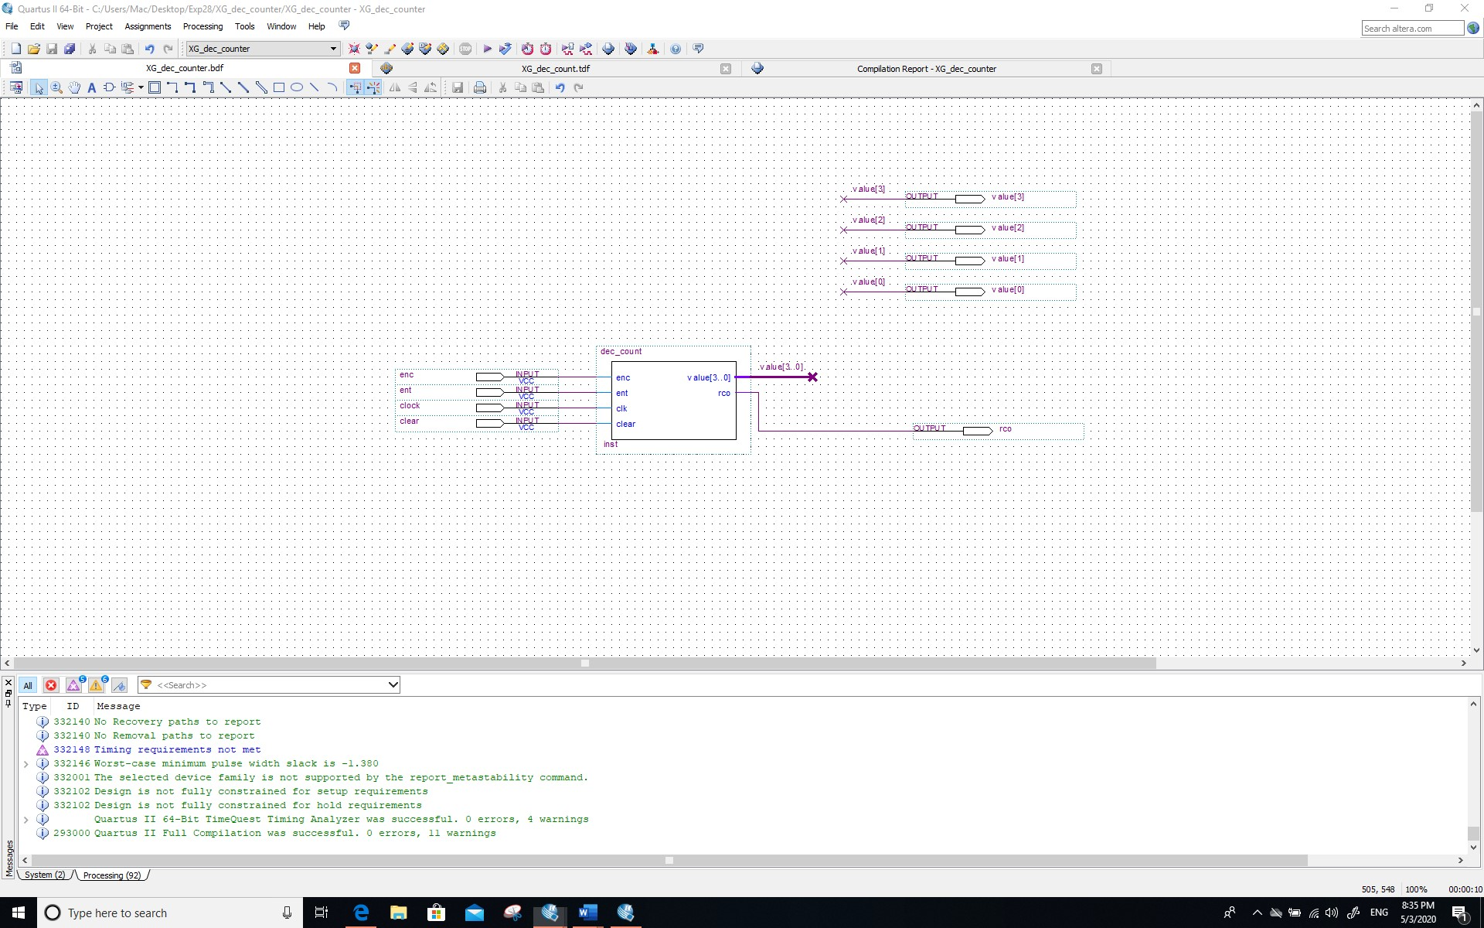

**Comment/Explanation:**

**By using the AHDL to define the dec-count from 0 to 9 (count 10), the schematic is shown in the figure. Also, the output is connected to a bus.**

1. **The** **simulation waveforms of Section** ‎**3.1 [4 Marks]**

**Screenshots of counter simulation:**

*Screenshot (PrintScreen or equivalent):*

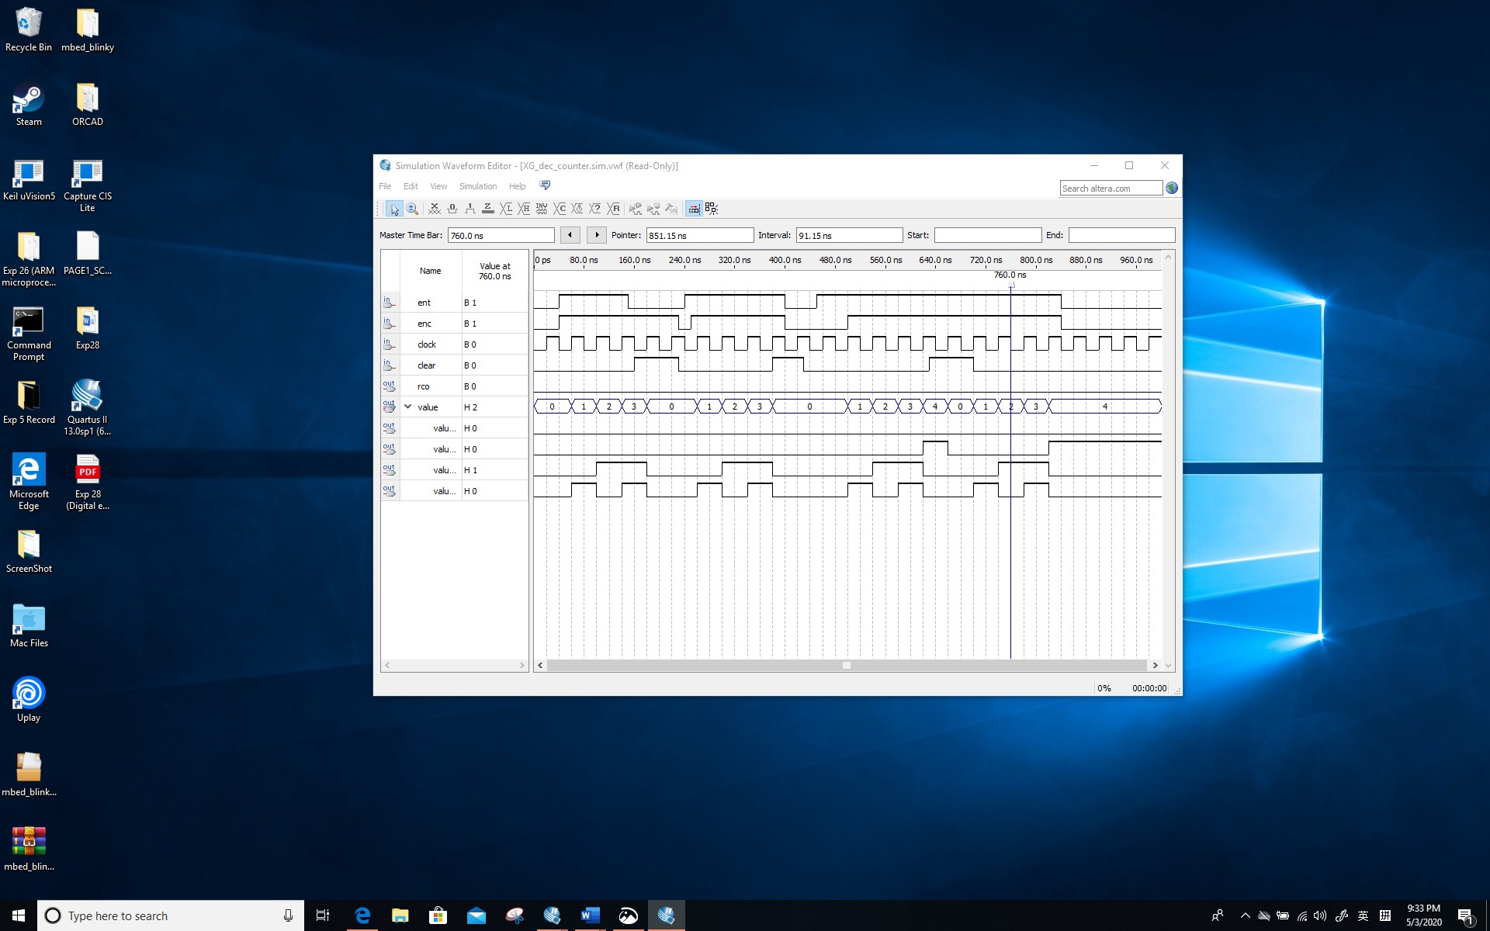

*Screenshot (Snipping tool or equivalent):*

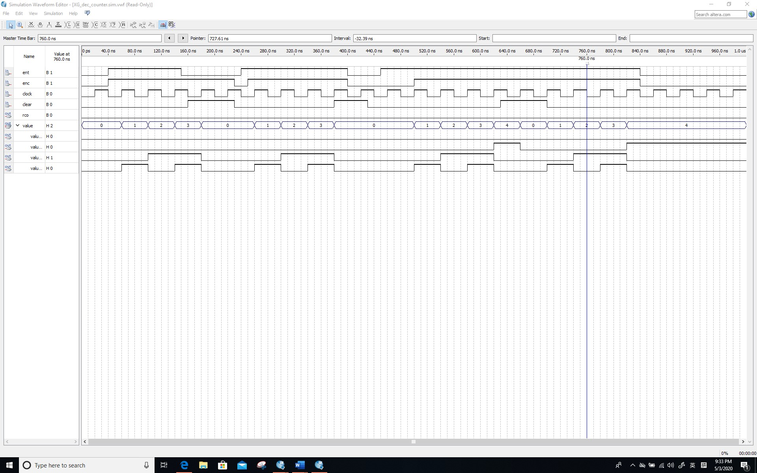

**Screenshots of simulation of counter connected to 7-segment decoder:**

*Screenshot (PrintScreen or equivalent):*

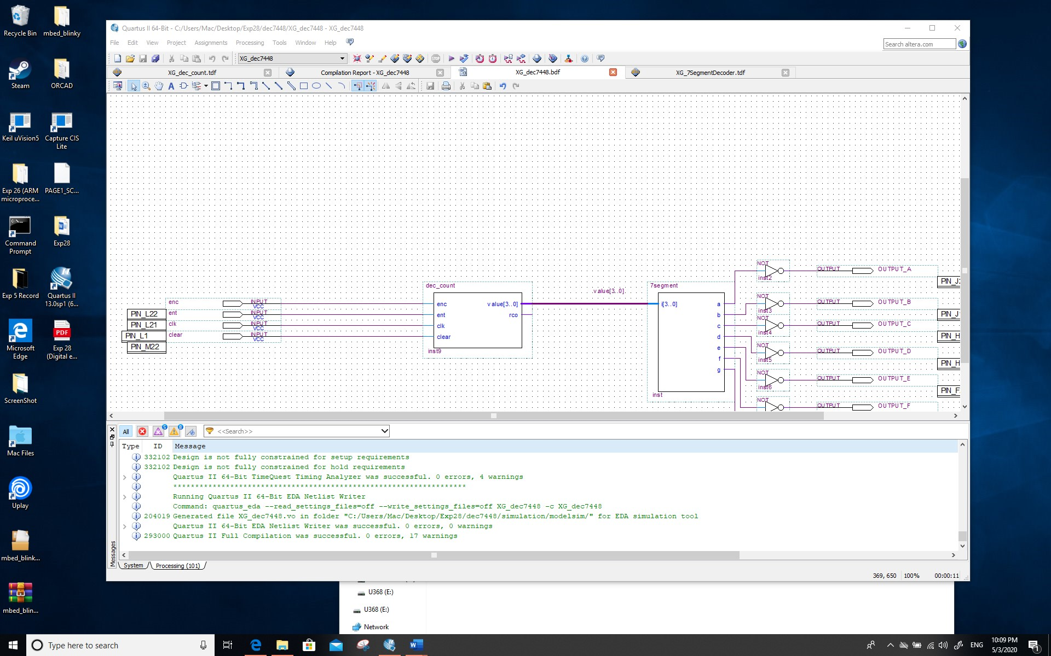

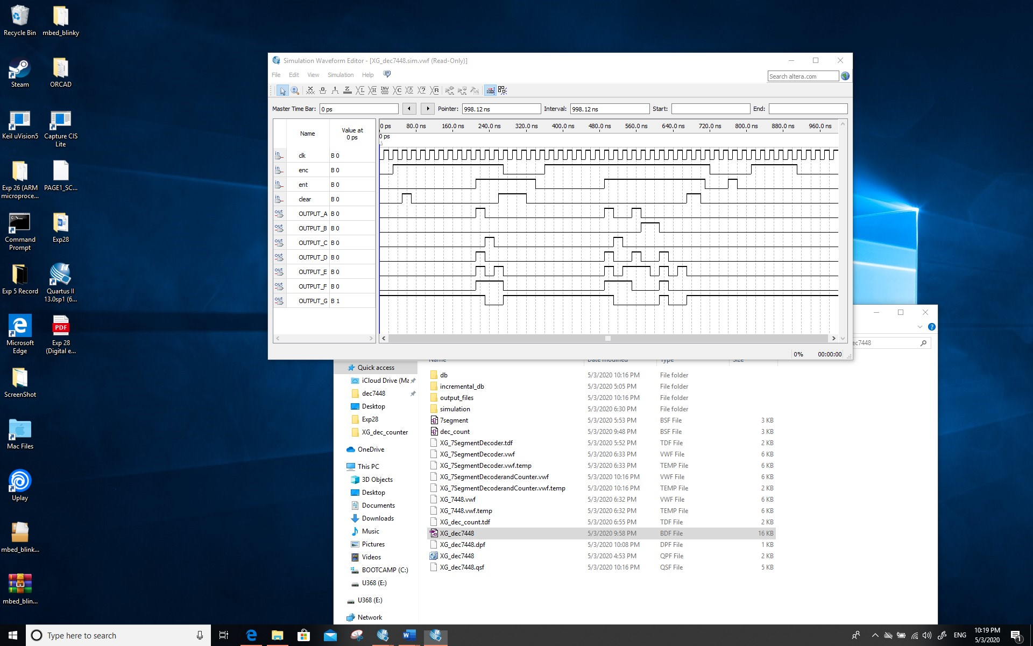

*Screenshot (Snipping tool or equivalent):*

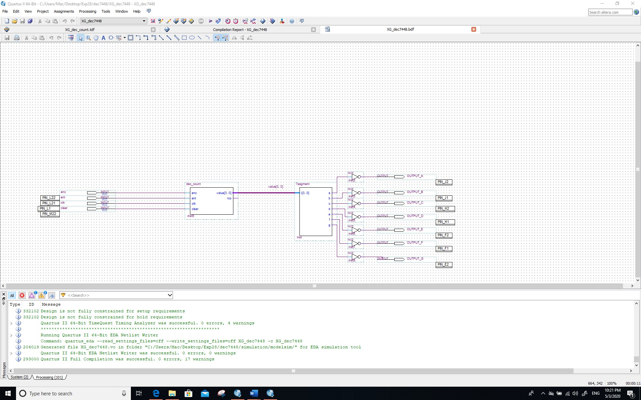

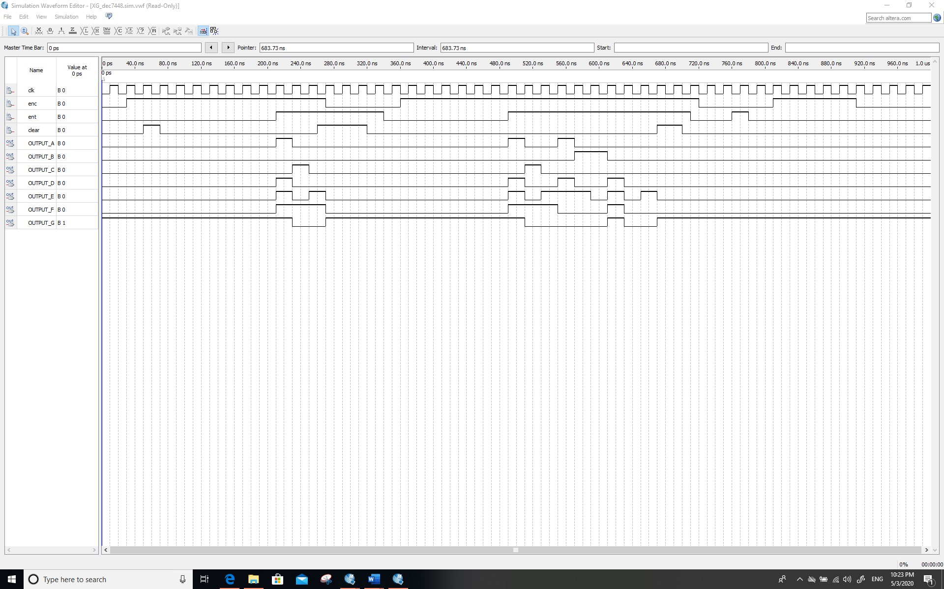

**Comment/Explanation:**

1. **The simulation waveforms of Section** ‎**3.1**

**For counters there are four cases: (1) if Clear is 1, the counter zeroing step is not affected by enc and ent, and zeroing along the next clock rise; (2) if both enc and ent are on and the sum of counters is not 9, the counter is added one; (3) if both enc and ent are on and the sum of counters is 9, the counter is zeroed out;(4) If either enc or ENT is not 1, the counter does not change along the rise of the clock. Furthermore, RCO is 1 if and only if the sum of the counters is 9 and ent is 1.**

1. **Simulation of counter connected to 7-segment decoder**

**The counter and 7-segment decoder are connected together to form a diode display which can count 0-9. When the CLR is pressed manually, the counter is cleared, and the display also shows 0. Similarly, if the enc and ent are not pressed, the counting will not be performed. In other cases, the counter and 7-segement will be counted normally.**

1. **The initial schematic of Section** ‎**3.2 with pin assignments [4 Marks]**

**Screenshot (PrintScreen or equivalent):**

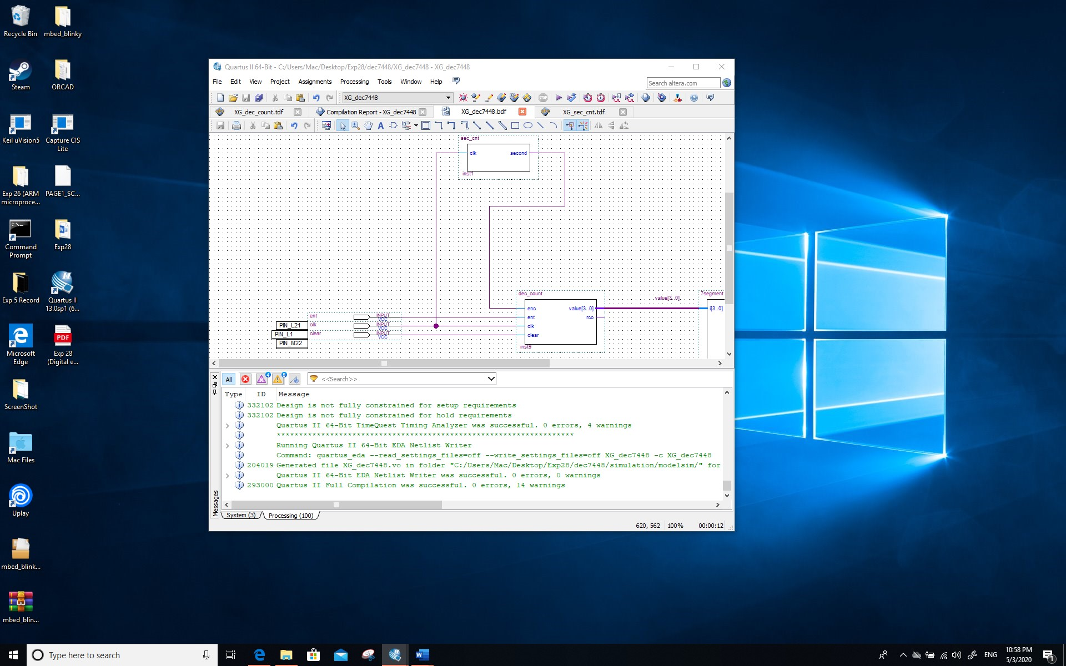

**Screenshot (Snipping tool or equivalent):**

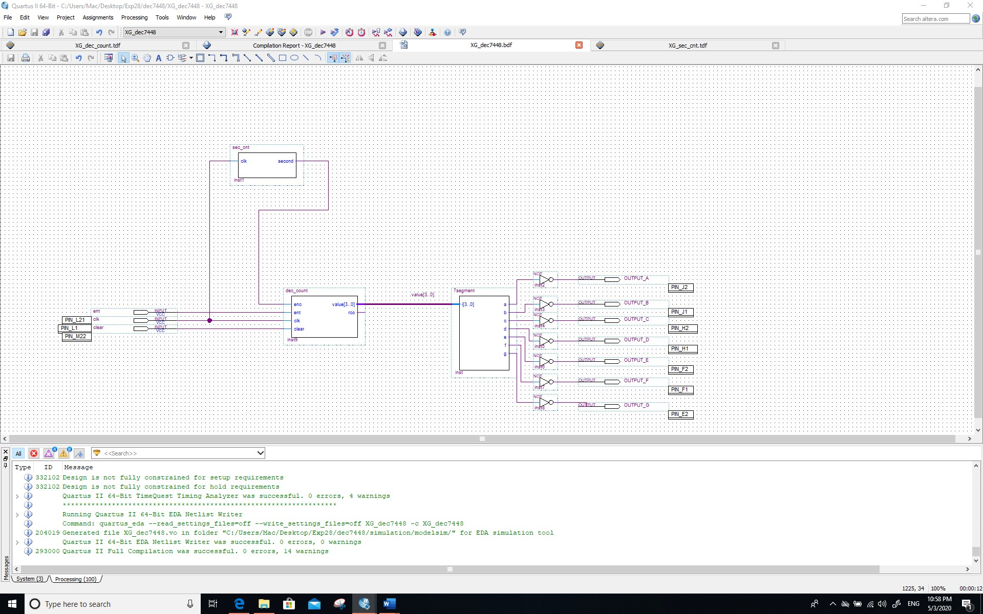

**Comment/Explanation:**

**The pin has been assigned into the schematic.**

1. **The simulation waveform and its explanation of Section 3.2 [4 Marks]**

**Screenshot (PrintScreen or equivalent):**

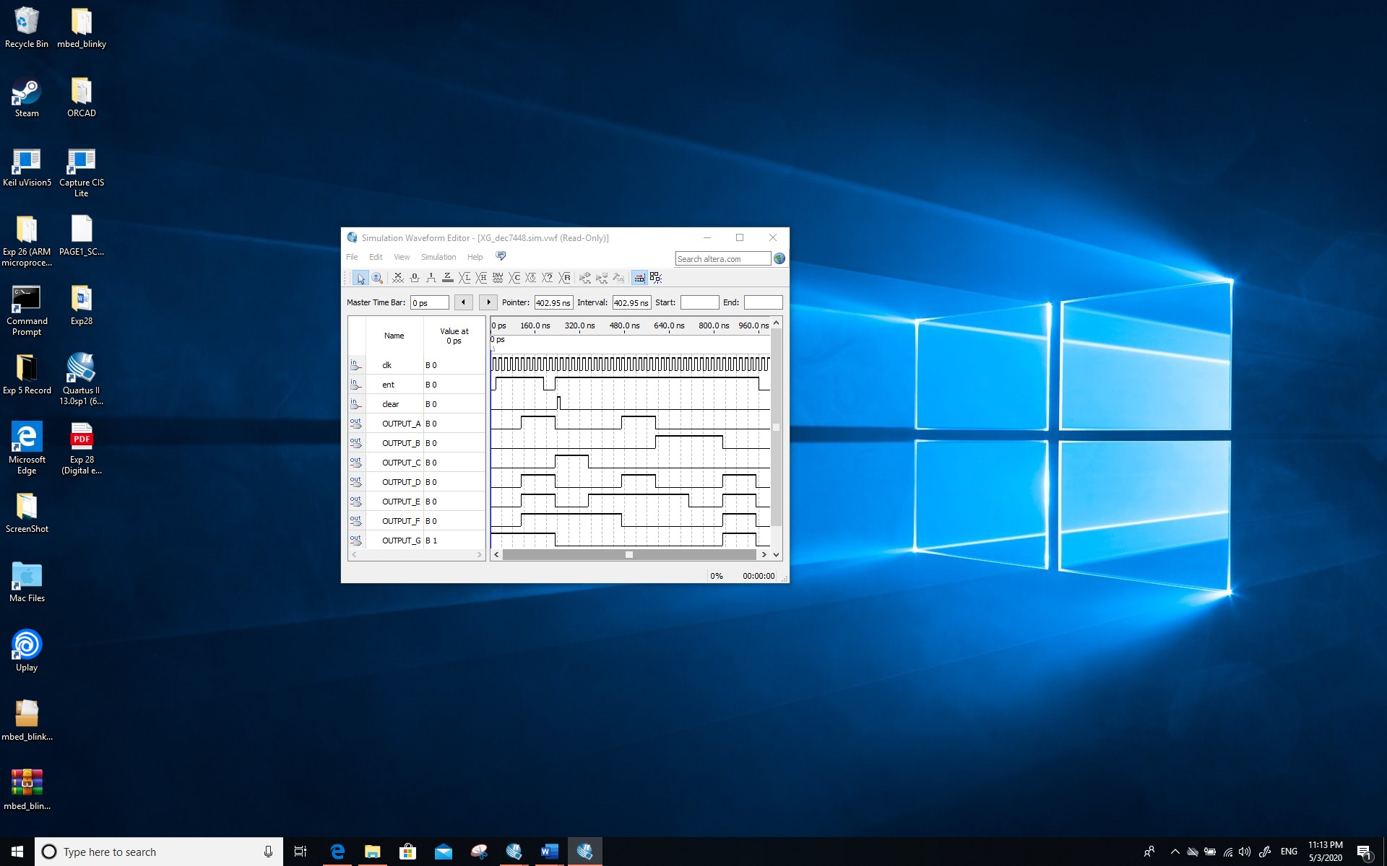

**Screenshot (Snipping tool or equivalent):**

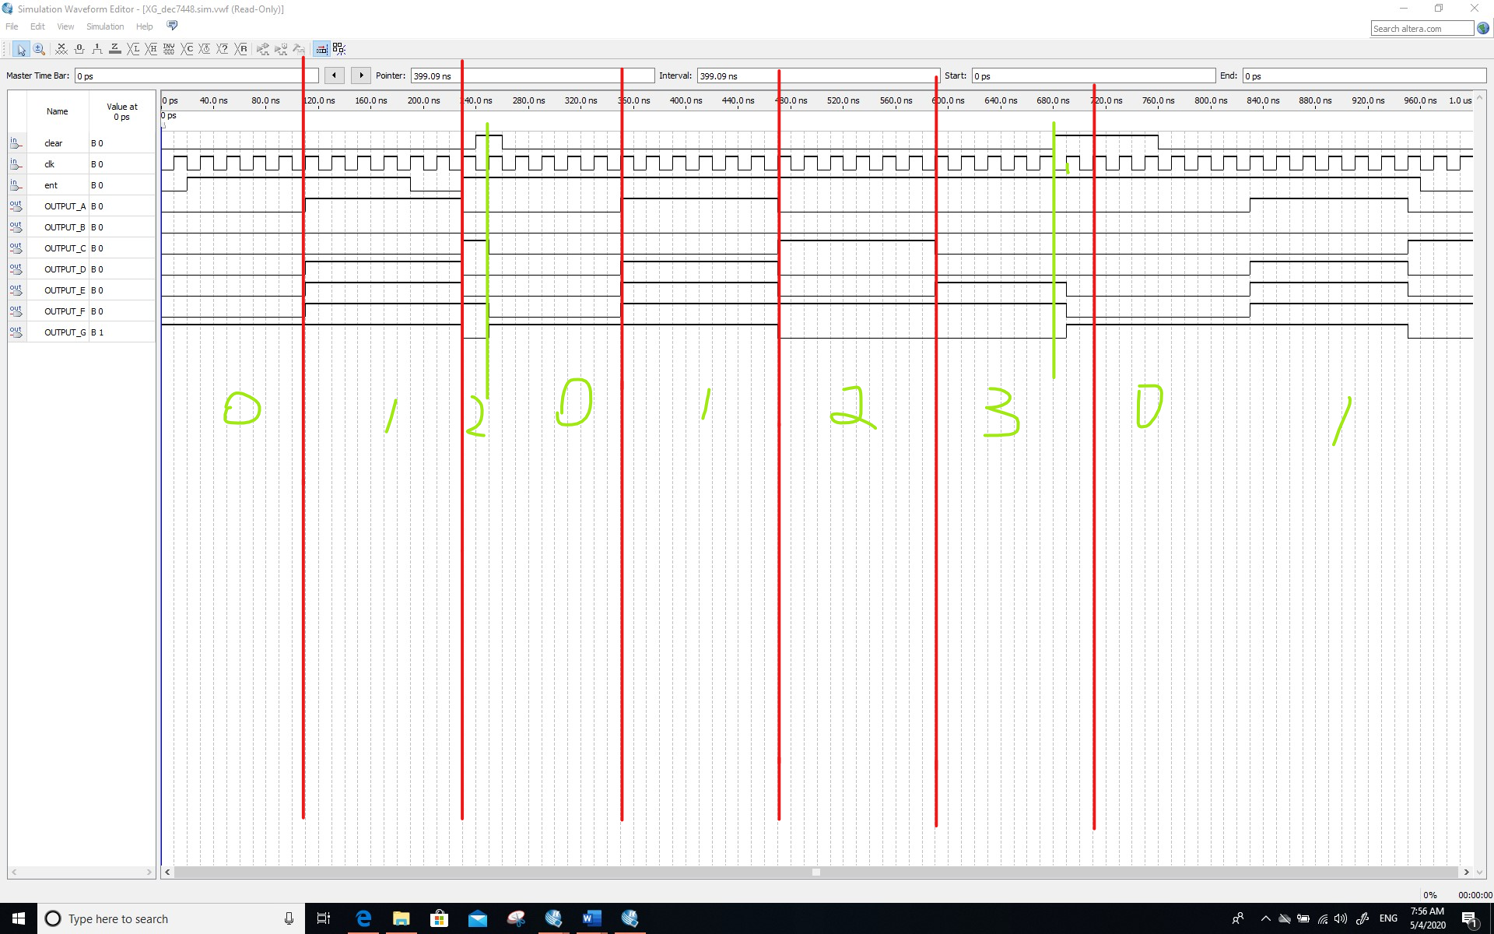

**Comment/Explanation:**

**The counter has been set to 5, but since the counter is incremented from 0 to 5 it actually passes through six clock signals before being changed as a single time. In the figure, it can be concluded that the number of the first 7-segment is 0, after 6 clock cycles, the number of the 7-segment is 1, after 6 clock cycles again, the number is 2, but at this time the CLR is pressed, after the next clock rising edge when the CLR is pressed, the counter is cleared and the counting starts again. In addition, since ent changes to 1 in the next six clock cycles, the counter continuous to count.**

**The clock period corresponding to 50 MHz should be 20 nanoseconds. Please note that the clock cycle of this picture is already 20ns, and if 20ns times 50000000, it should be 1s, so the counter should be updated in 1s, but it is not, because there are 50000001 clock cycles from 0 to 50000000.**

**So the file should be modified to 4999999 in order to change the clock change time to 1s.**

1. **The schematic and simulation of the divide-by-12, and of the**

**cascading of two divide-by-12 counters, of Section 3.2 [10 Marks]**

**Screenshots of divide-by-12 (schematic design):**

**Screenshot (PrintScreen or equivalent):**

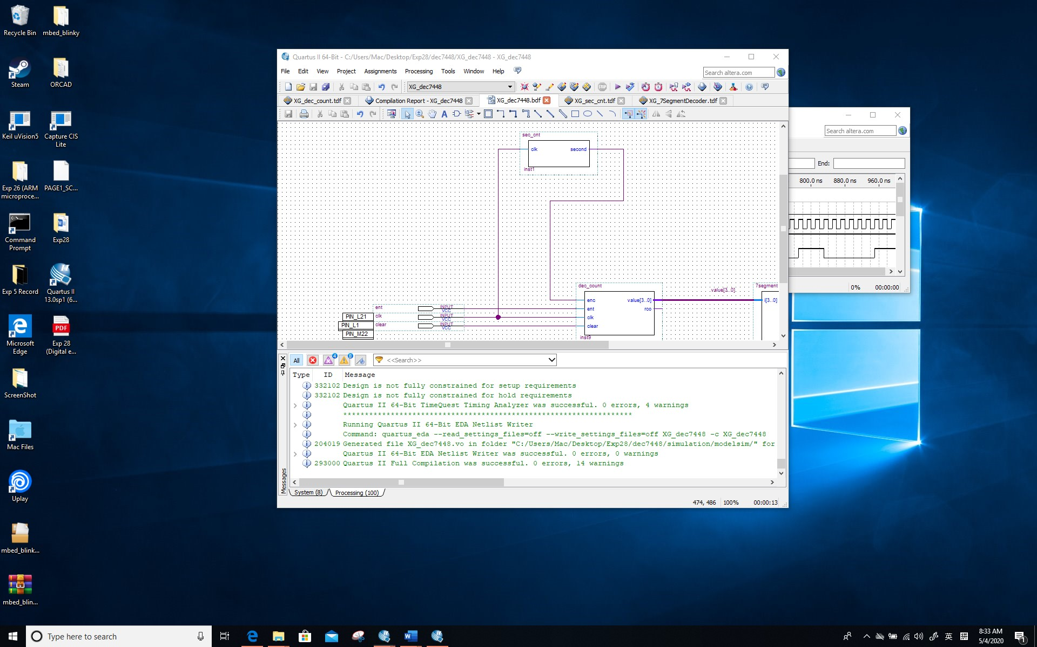

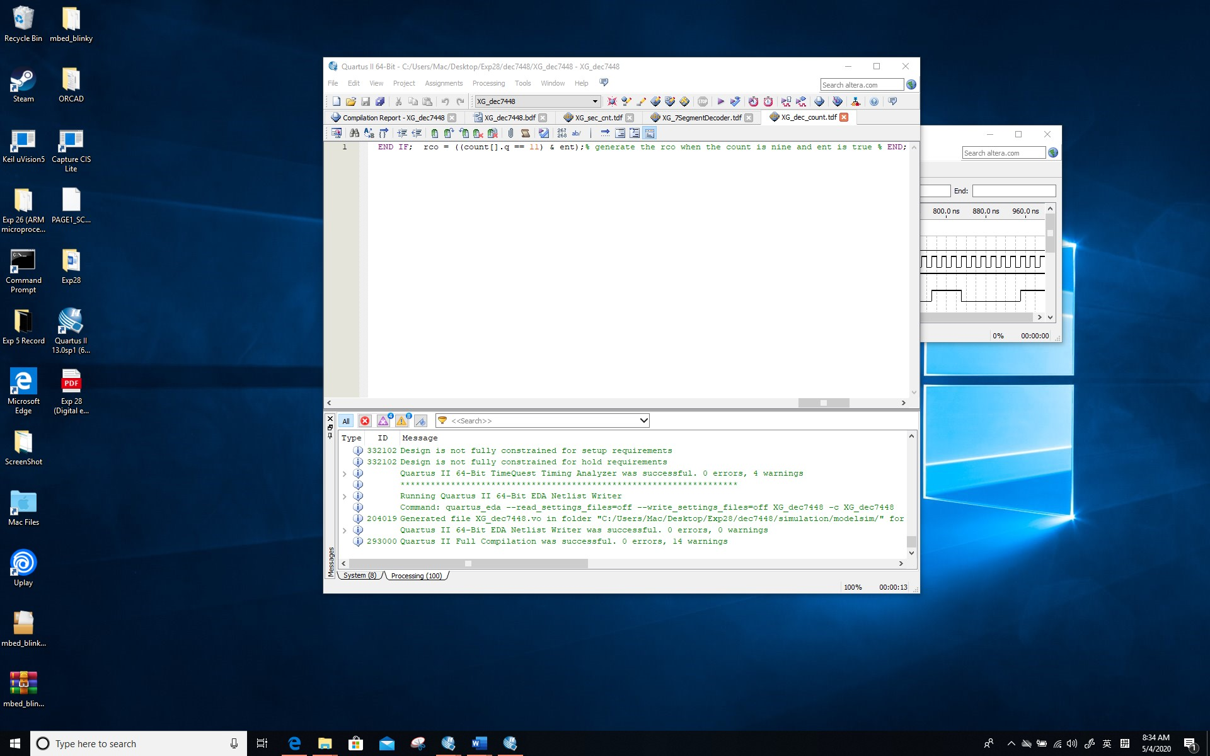

**Screenshot (Snipping tool or equivalent):**

**The sec_counter has been set to 2 for easy to count (ie. 3 time clock)**

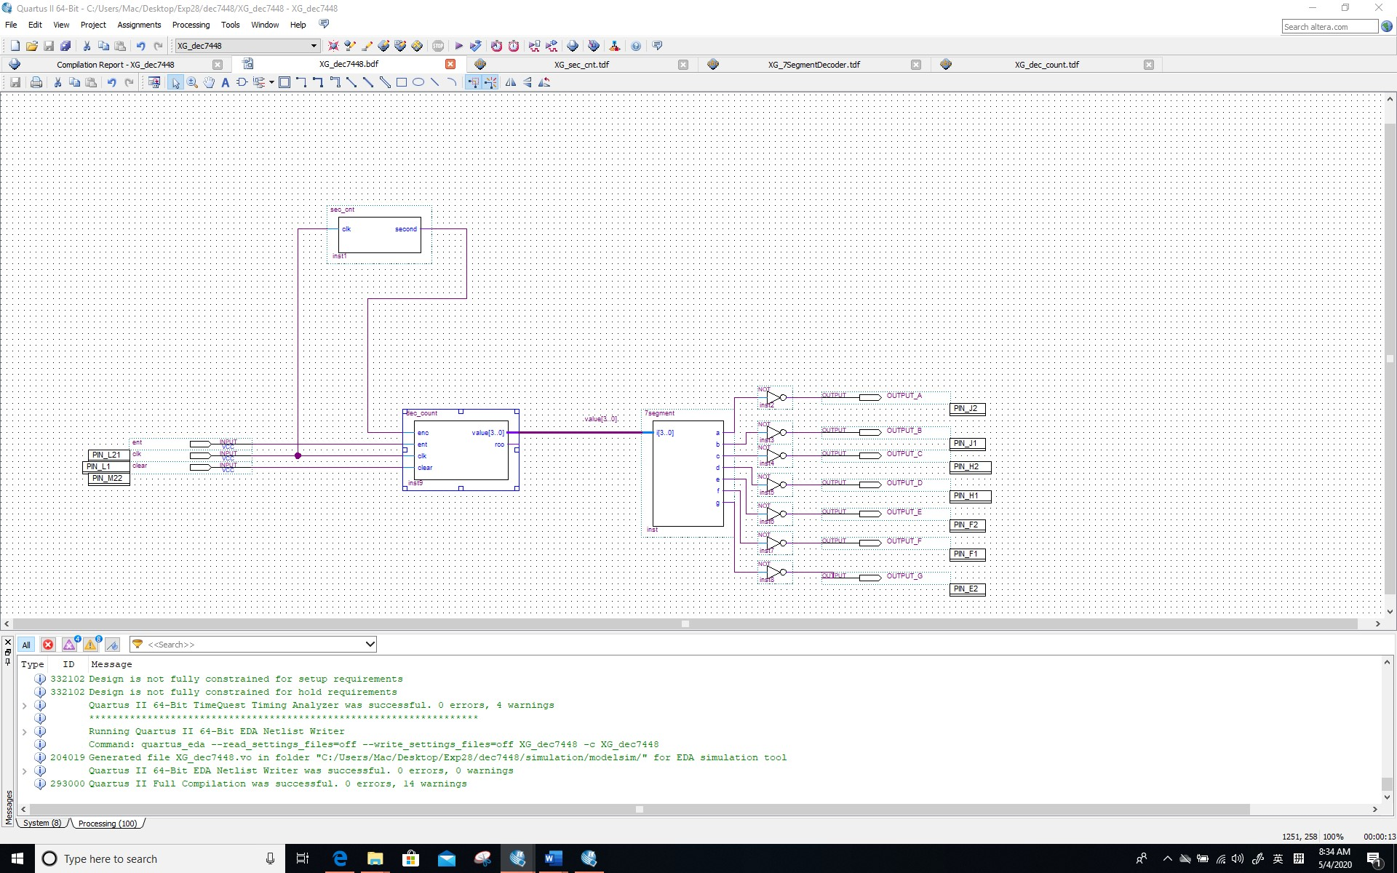

**Screenshots of divide-by-12 (simulation)**

*Screenshot (PrintScreen or equivalent):*

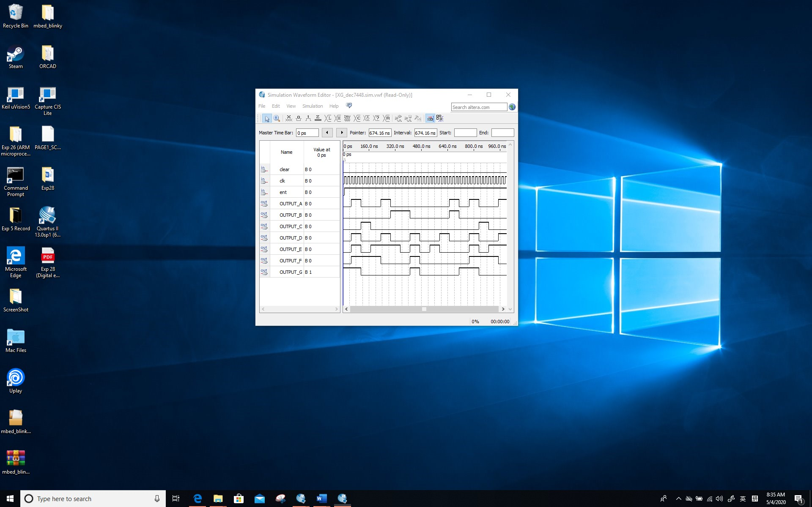

*Screenshot (Snipping tool or equivalent):*

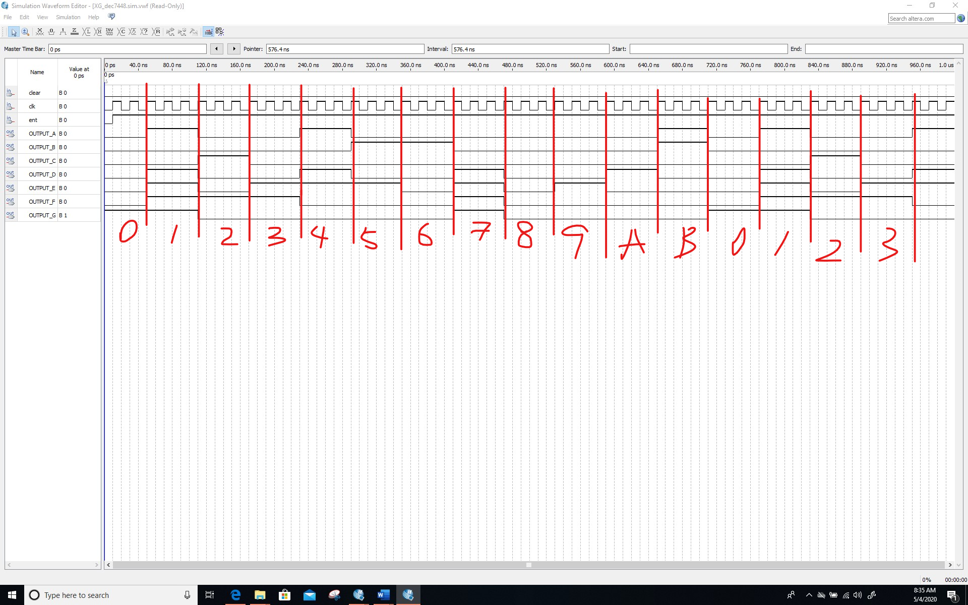

**Comment/Explanation:**

**The counter has now been modified to a module 12 counter by editing the code. In order to clearly show that the counter can count to 12, the time counter has been modified to 2 for test, that is, to count the rise edge once after three clock cycles.**

**Screenshots of cascading (schematic design):**

*Screenshot (PrintScreen or equivalent):*

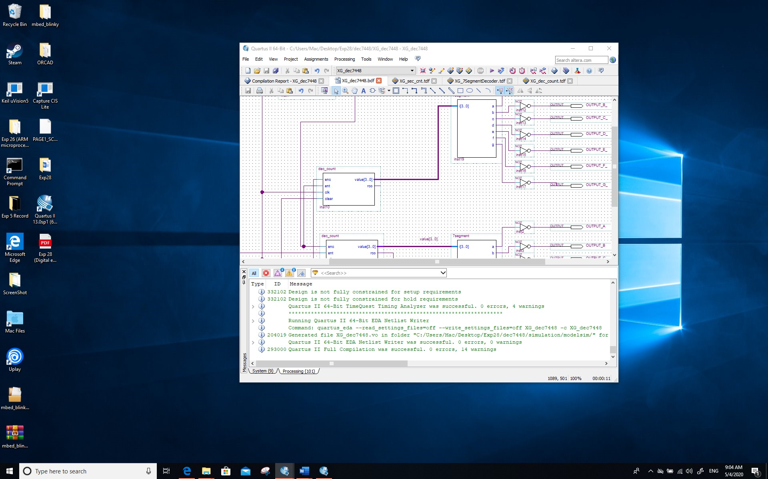

*Screenshot (Snipping tool or equivalent):*

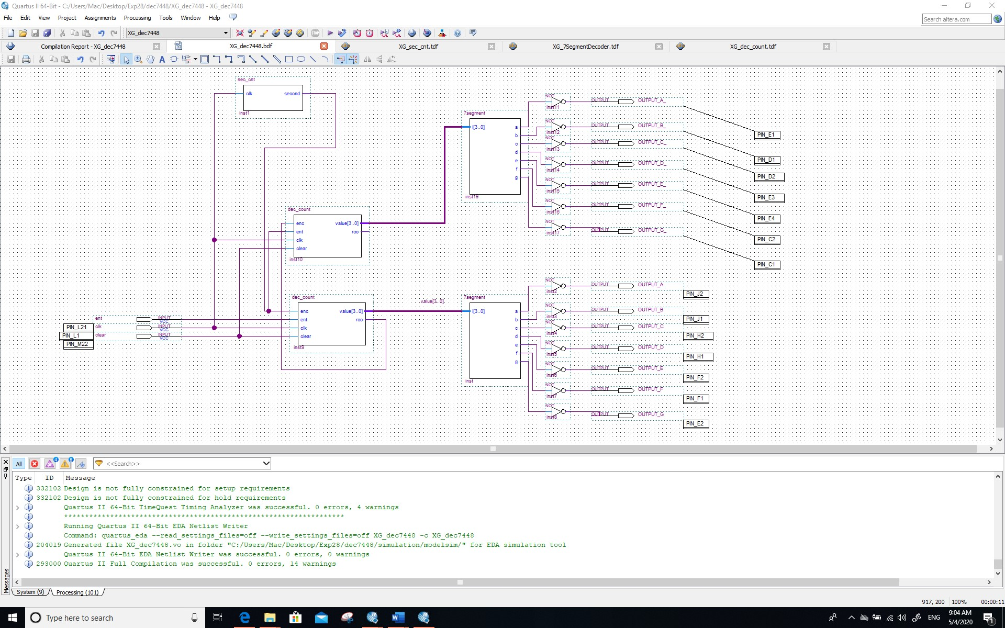

**Screenshots of cascading (simulation)**

*Screenshot (PrintScreen or equivalent):*

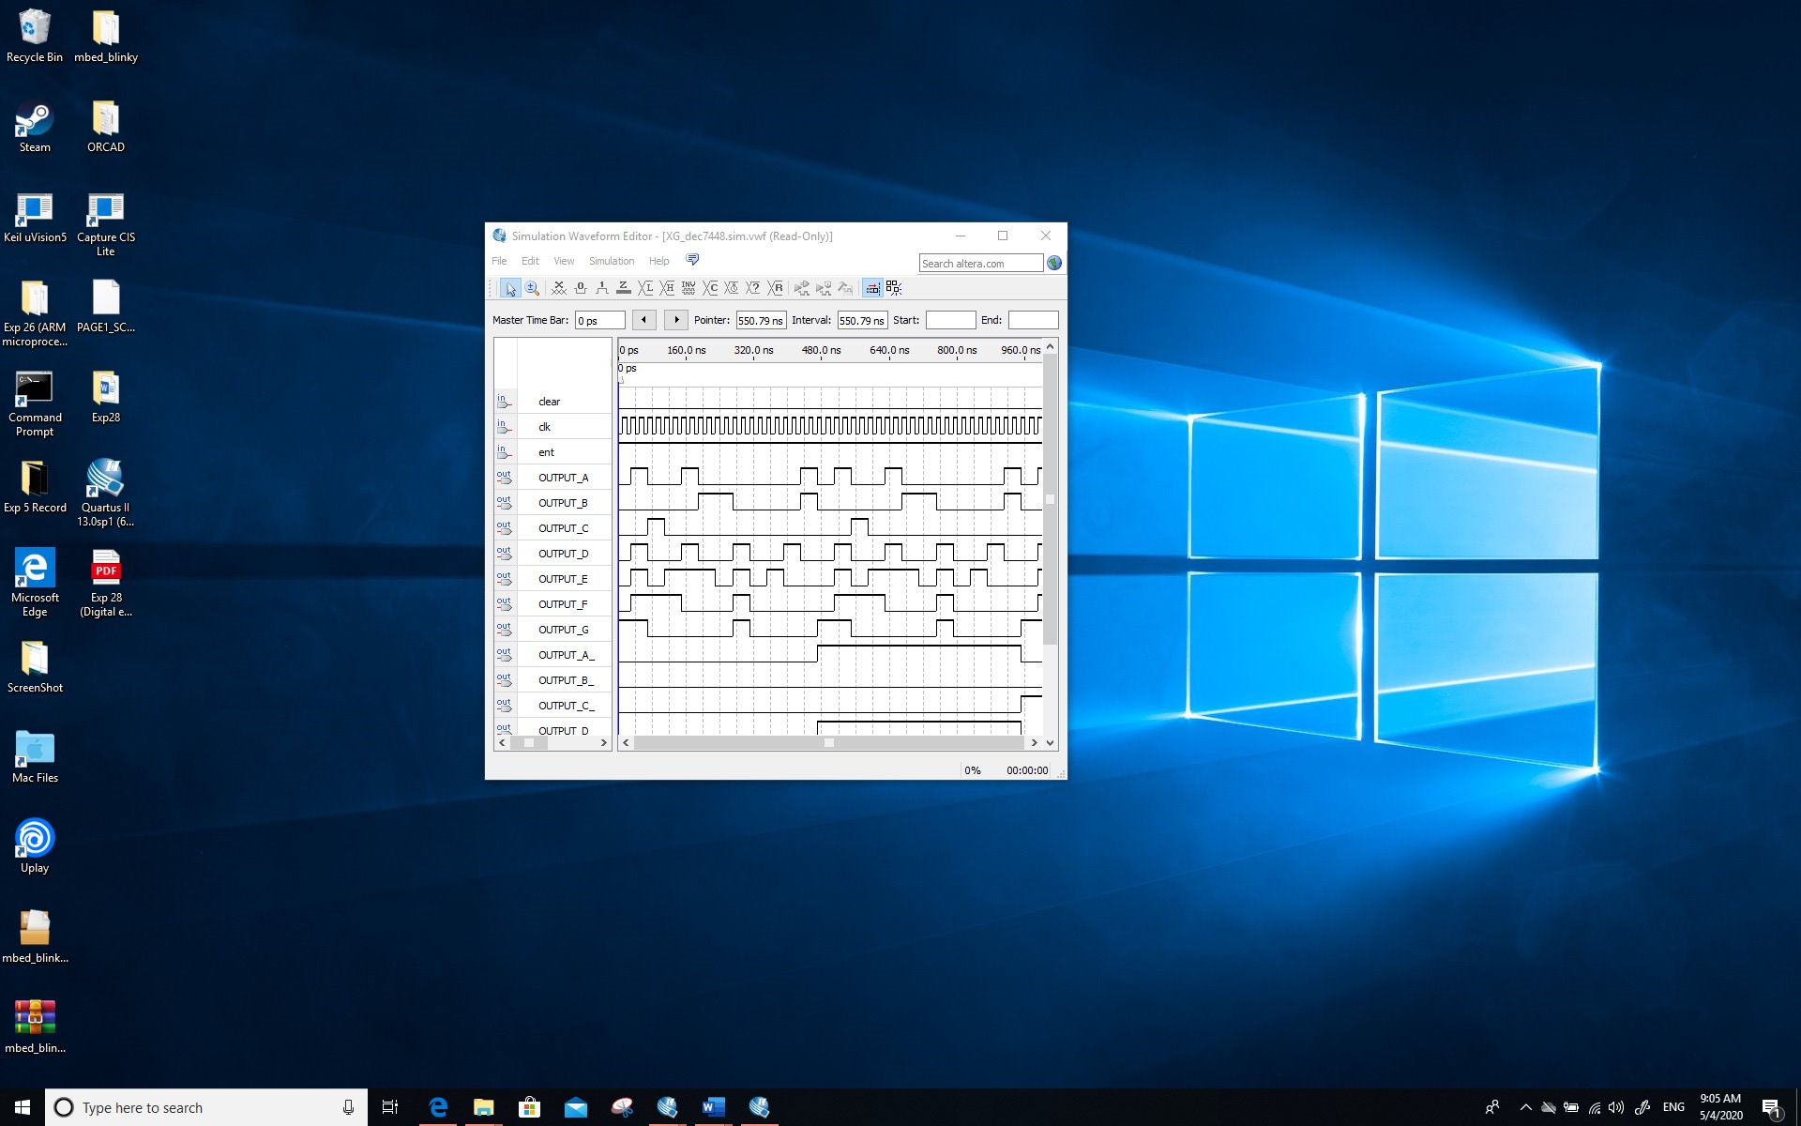

*Screenshot (Snipping tool or equivalent):*

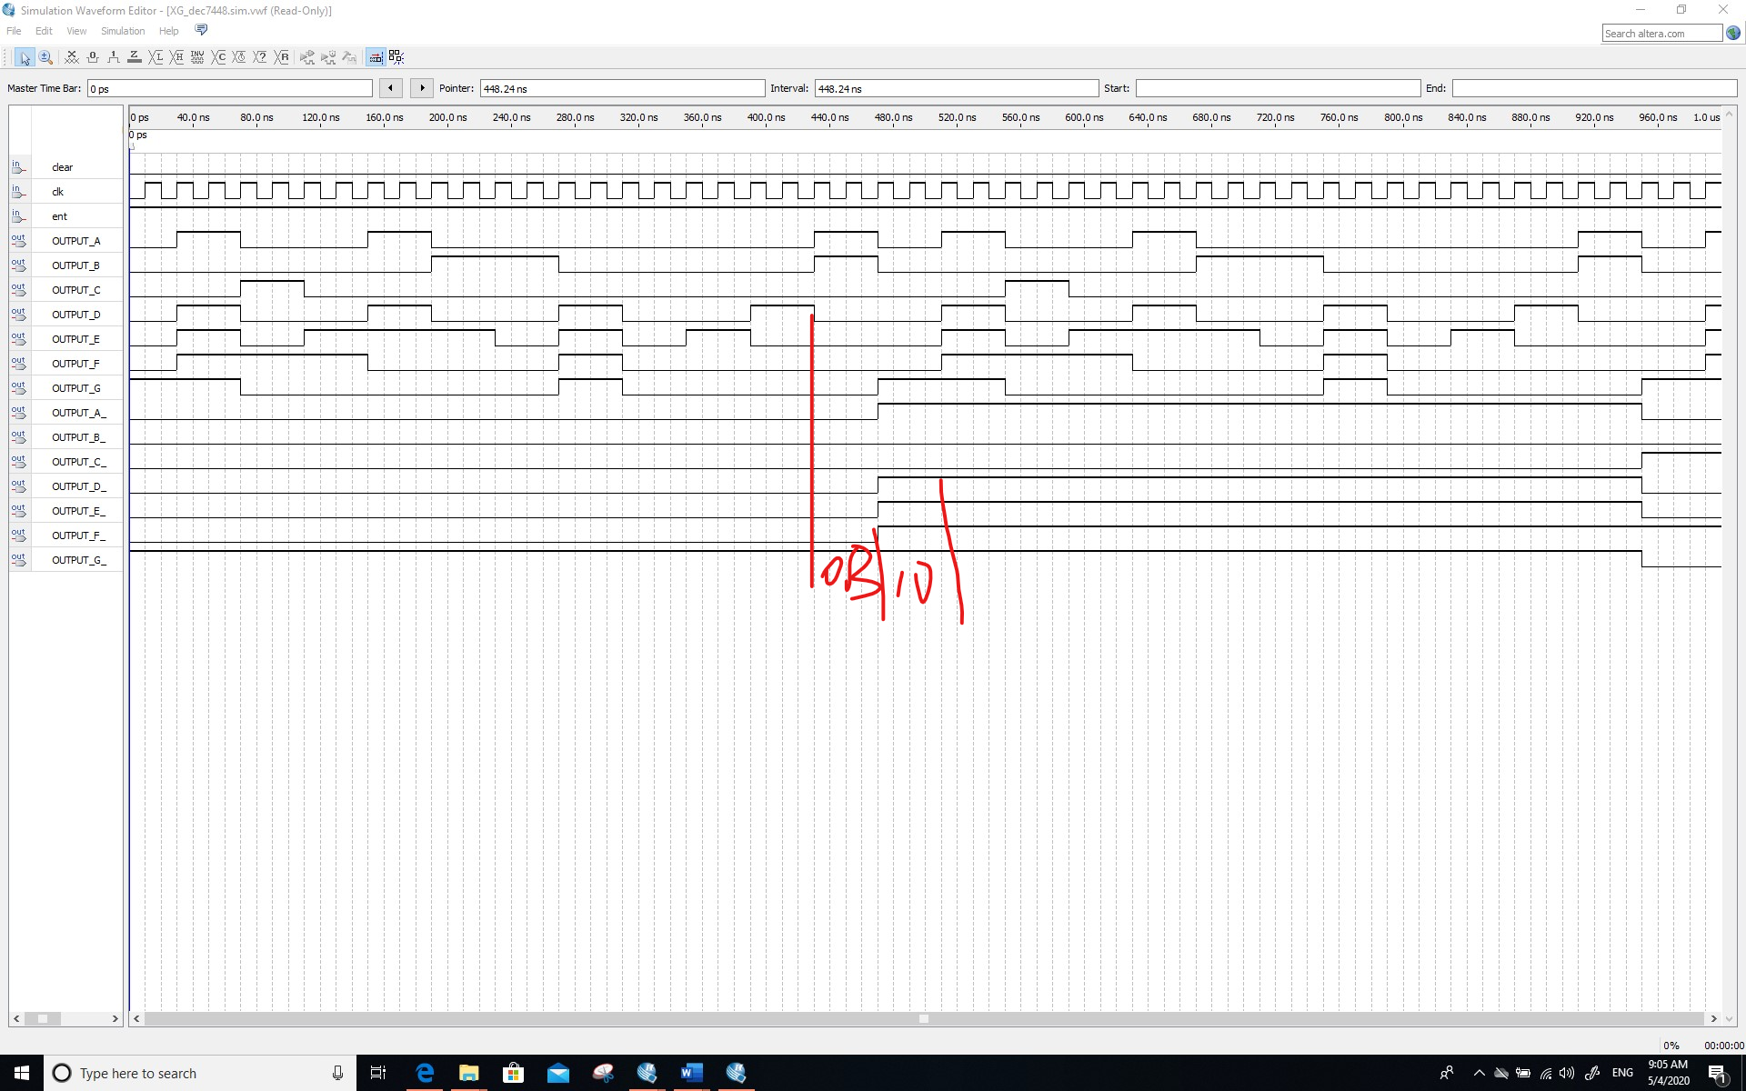

**Comment/Explanation:**

**As shown in the figure, two counters are combined and RCO is used to trigger the carry of the next counter. The result shows that the counting function is correct. As shown in the figure. First, OUTPUTX starts counting. At this time, OUTPUTX_ does not count and only keeps. When the first counter counts to B, RCO is one, so the next counter carries. The figure shows the carry step of the counter.**

1. **The code and annotated simulations of Section 4.1 [10 Marks]**

**The code (as text):**

***SUBDESIGN state***

***(***

***clk :INPUT;***

***reset :INPUT;***

***%The clear%***

***key1 :INPUT;***

***z :OUTPUT;***

***%The output z %***

***)***

***VARIABLE ss : MACHINE OF BITS ( z ) WITH STATES***

***(***

***s0 = 0 ,***

***s1 = 0 ,***

***s2 = 1 ,***

***s3 = 0***

***);***

***BEGIN ss . clk = clk ; ss . reset = reset ;***

***TABLE***

***% current state , current input=> next state %***

***ss , key1 => ss ;***

***s0 , 0 => s0 ;***

***s0 , 1 => s1 ;***

***s1 , 0 => s0 ;***

***s1 , 1 => s2 ;***

***s2 , 0 => s0 ;***

***s2 , 1 => s3 ;***

***s3 , 0 => s0 ;***

***s3 , 1 => s3 ;***

***END TABLE;***

***END;***

**Screenshots of the simulations:**

**Screenshot(s) (PrintScreen or equivalent):**

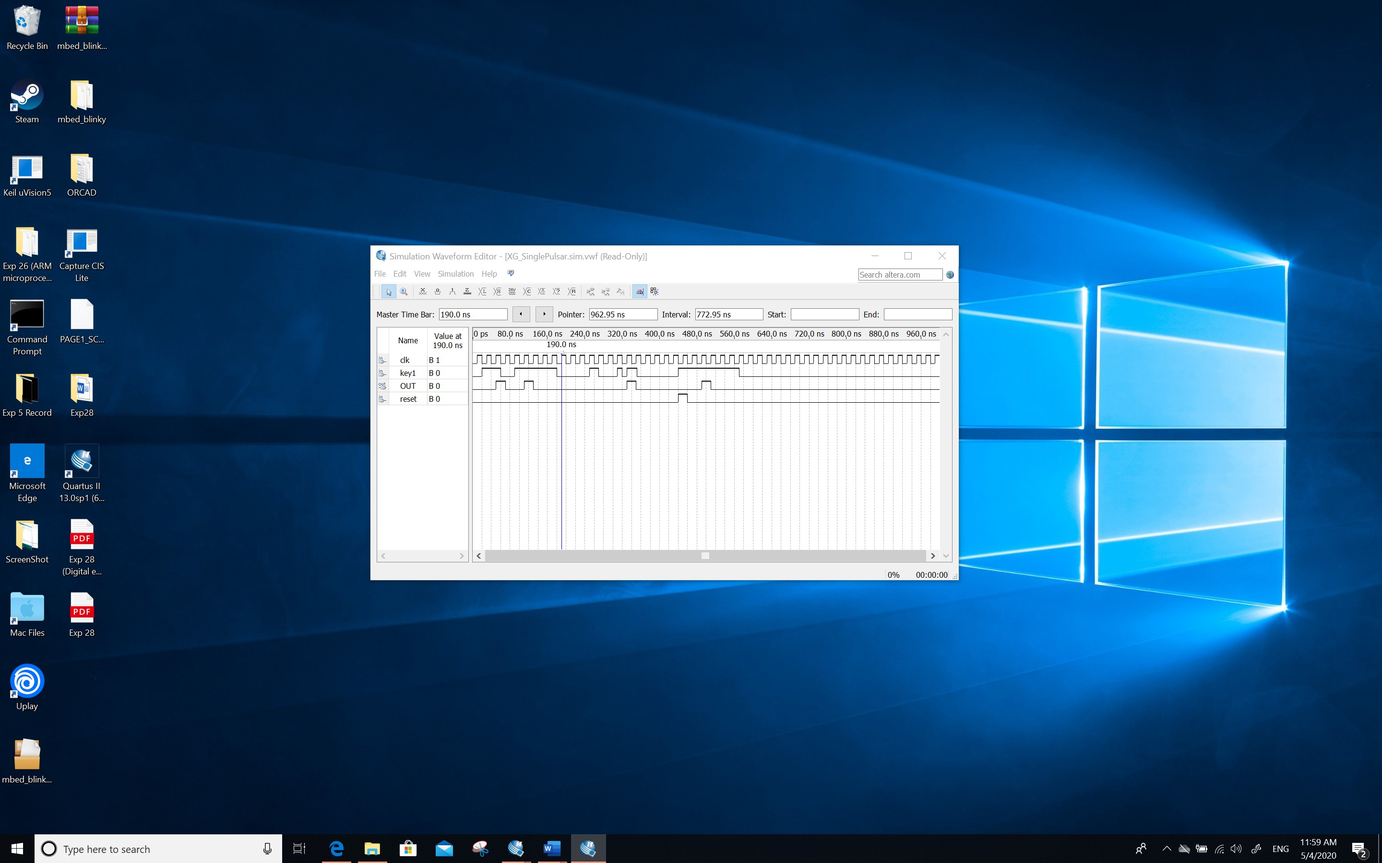

**Screenshot(s) (Snipping tool or equivalent):**

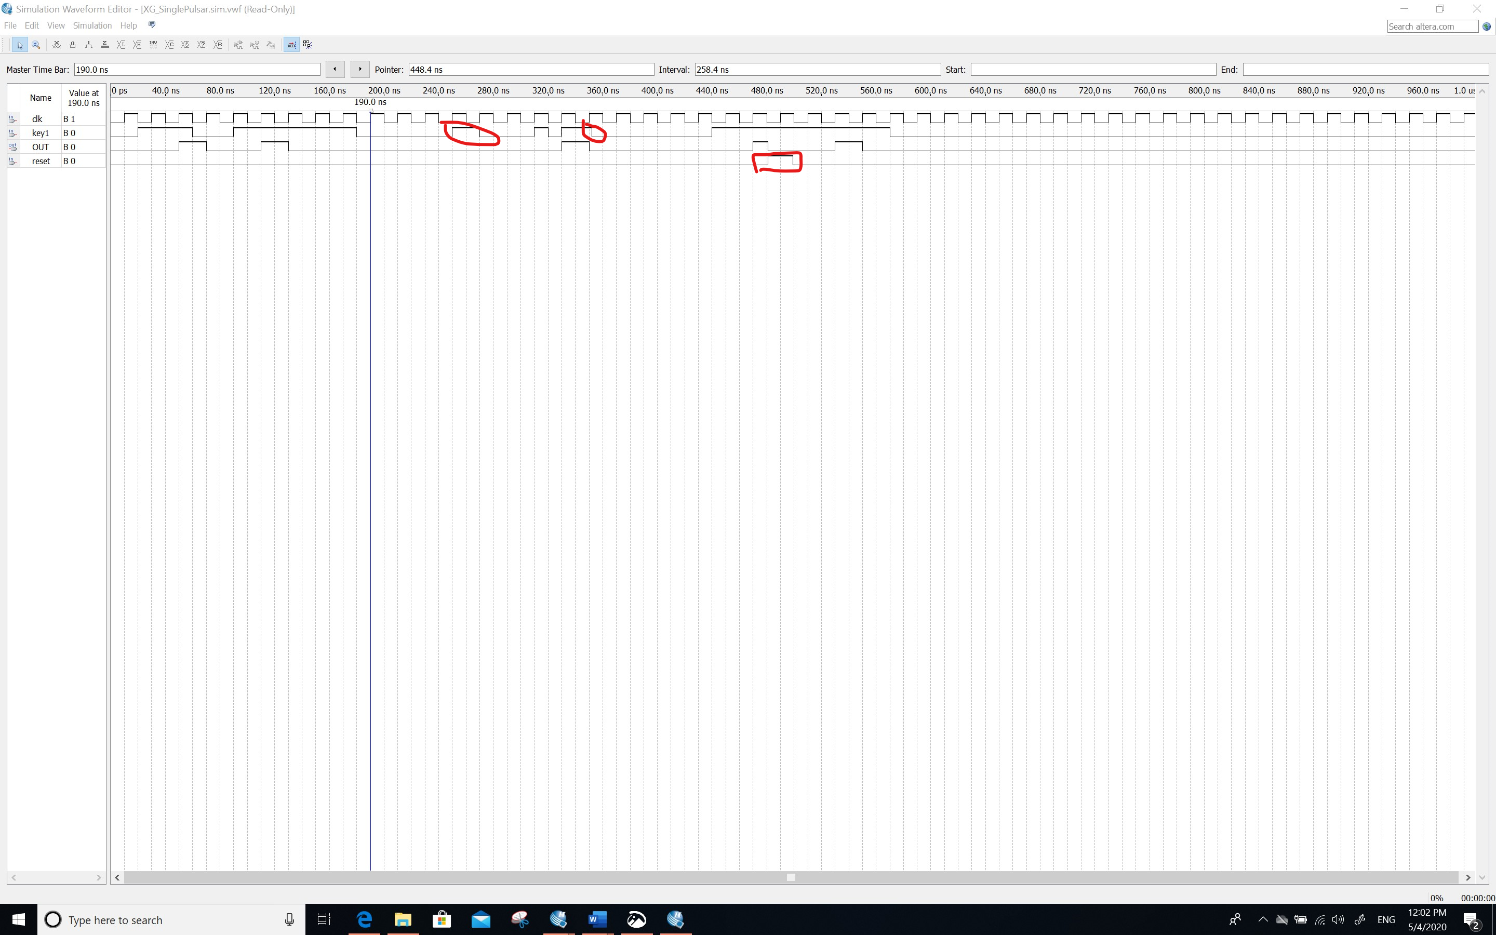

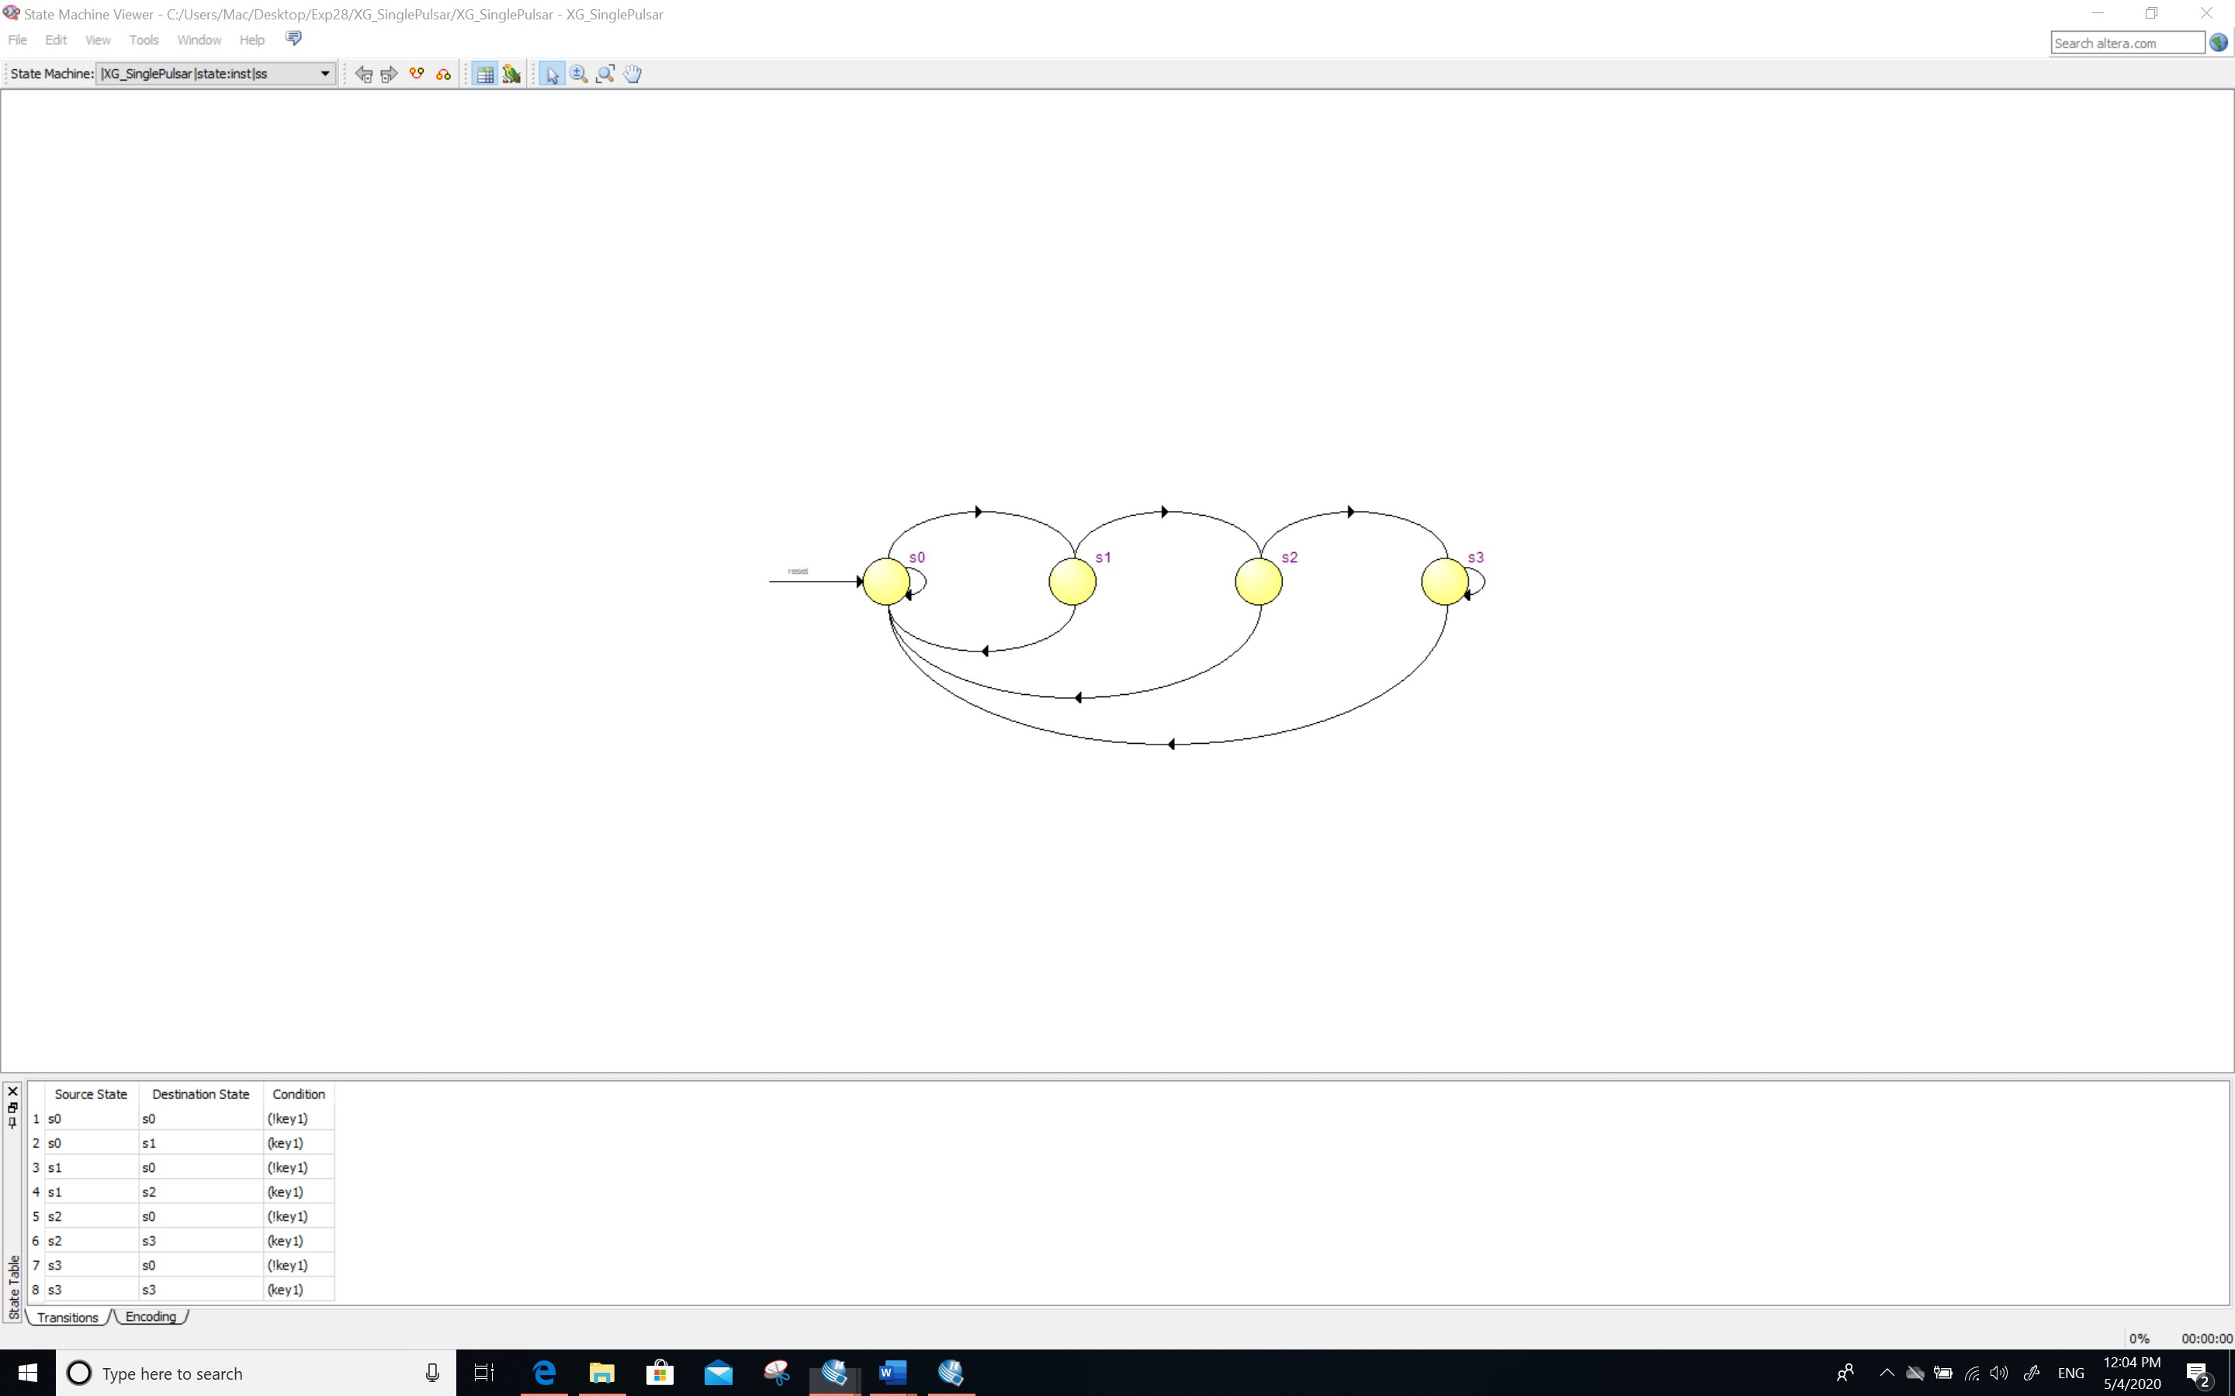

**Comment/Explanation:**

**For the first S0, if the key1 is enter then jump to the S1, else if key1 is not pressed, then S0 return to the S1.**

**For the S1, if then user press not one time cycle, then return to S0, else S1 jump to S2 if the key is pressed longer than one time cycle, then the S2 is determined whether the user hold the button, if user hold key1, then jump to the S3 else jump to S0, for the state 3, if user continuous press key1, then give the output 0 (To prevent output 1 again), if the user stop hold the key1, jump to the S0 state.**

**The simulation verifies that the requirements are met, if the keys are pressed within a constant range(in one cycle), the output will not react, if the keys are pressed for more than a clock cycle, the output will be 1, when the user presses the button for a long time, the state of the system will enter S3, and the output will be 0; when the user stops pressing the button, the state will be restored to S0; in addition, when the CLR input, can return to state 0 in any state.**

1. **The code, schematic design and** annotated **simulations of Section 4.2 [10 Marks]**

**The code (as text):**

***% -a- %***

***% f| |b %***

***% -g- %***

***% e| |c %***

***% -d- %***

***% %***

***% 0 1 2 3 4 5 6 7 8 9 A b C d E F %***

***% %***

***SUBDESIGN 7segment***

***(***

***i[3..0] : INPUT;***

***a, b, c, d, e, f, g : OUTPUT;***

***)***

***BEGIN TABLE***

***i[3..0] => a, b, c, d, e, f, g; H"0" => 1, 1, 1, 1, 1, 1, 0;***

***H"1" => 0, 1, 1, 0, 0, 0, 0;***

***H"2" => 1, 1, 0, 1, 1, 0, 1;***

***H"3" => 1, 1, 1, 1, 0, 0, 1;***

***H"4" => 0, 1, 1, 0, 0, 1, 1;***

***H"5" => 1, 0, 1, 1, 0, 1, 1;***

***H"6" => 1, 0, 1, 1, 1, 1, 1;***

***H"7" => 1, 1, 1, 0, 0, 0, 0;***

***H"8" => 1, 1, 1, 1, 1, 1, 1;***

***H"9" => 1, 1, 1, 1, 0, 1, 1;***

***H"A" => 1, 1, 1, 0, 1, 1, 1;***

***H"B" => 0, 0, 1, 1, 1, 1, 1;***

***H"C" => 1, 0, 0, 1, 1, 1, 0;***

***H"D" => 0, 1, 1, 1, 1, 0, 1;***

***H"E" => 1, 0, 0, 1, 1, 1, 1;***

***H"F" => 1, 0, 0, 0, 1, 1, 1;***

***END TABLE; END;***

***SUBDESIGN dec_count ( enc, ent, clk : INPUT; % two enables and the clock % clear : INPUT; % Synchronous clear % value[3..0] : OUTPUT; % Four output bits % rco : OUTPUT; % ripple carry out % ) VARIABLE count[3..0] : DFF; % locally define 4 D-Flip-Flops for the count % BEGIN count[].clk = clk; % Connect the clock input to the DFF’s clock % value[] = count[]; % connect the outputs of the DFFs to the outputs % IF (clear) THEN % if clear is true clear the count i.e. % count[].d = 0; % load the flipflops with zero % ELSIF (enc & ent & (count[].q != 9)) THEN % if both enables are true and the count does not % count[].d = count[].q + 1; % equal nine then add one to the count value % ELSIF (enc & ent & (count[].q == 9)) THEN % if both enables are true and the count does % count[].d = 0; % equal nine then load the flip flops with zero % ELSE % with no enable keep the flips flops at the same value % count[].d = count[].q; END IF; rco = ((count[].q == 9) & ent);% generate the rco when the count is nine and ent is true % END;***

***SUBDESIGN state***

***(***

***clk :INPUT;***

***reset :INPUT;***

***%The clear%***

***key1 :INPUT;***

***z :OUTPUT;***

***%The output z %***

***)***

***VARIABLE ss : MACHINE OF BITS ( z ) WITH STATES***

***(***

***s0 = 0 ,***

***s1 = 0 ,***

***s2 = 1 ,***

***s3 = 0***

***);***

***BEGIN ss . clk = clk ; ss . reset = reset ;***

***TABLE***

***% current state , current input=> next state %***

***ss , key1 => ss ;***

***s0 , 0 => s0 ;***

***s0 , 1 => s1 ;***

***s1 , 0 => s0 ;***

***s1 , 1 => s2 ;***

***s2 , 0 => s0 ;***

***s2 , 1 => s3 ;***

***s3 , 0 => s0 ;***

***s3 , 1 => s3 ;***

***END TABLE;***

***END;***

**Screenshots of the schematic design:**

*Screenshot (PrintScreen or equivalent):*

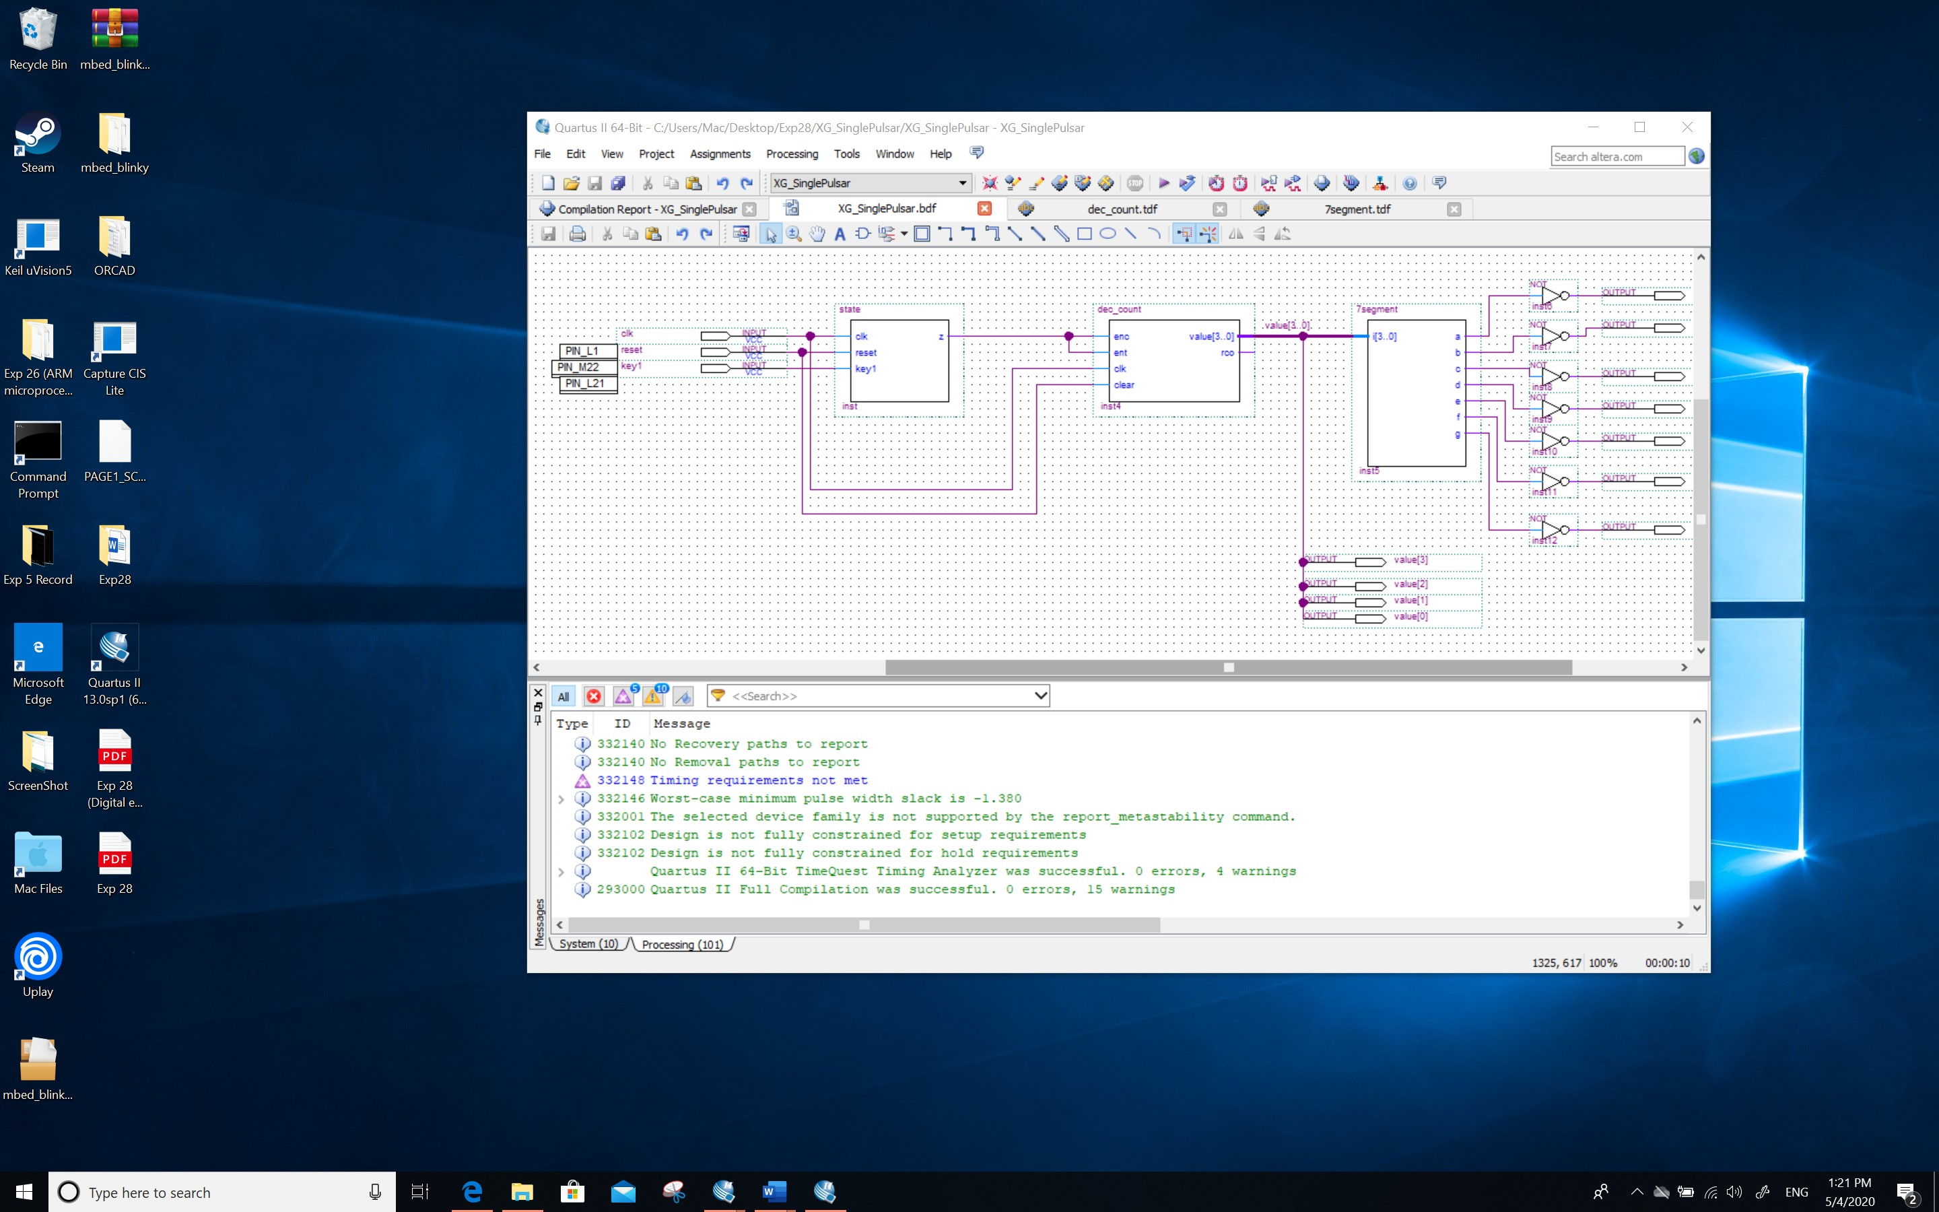

*Screenshot (Snipping tool or equivalent):*

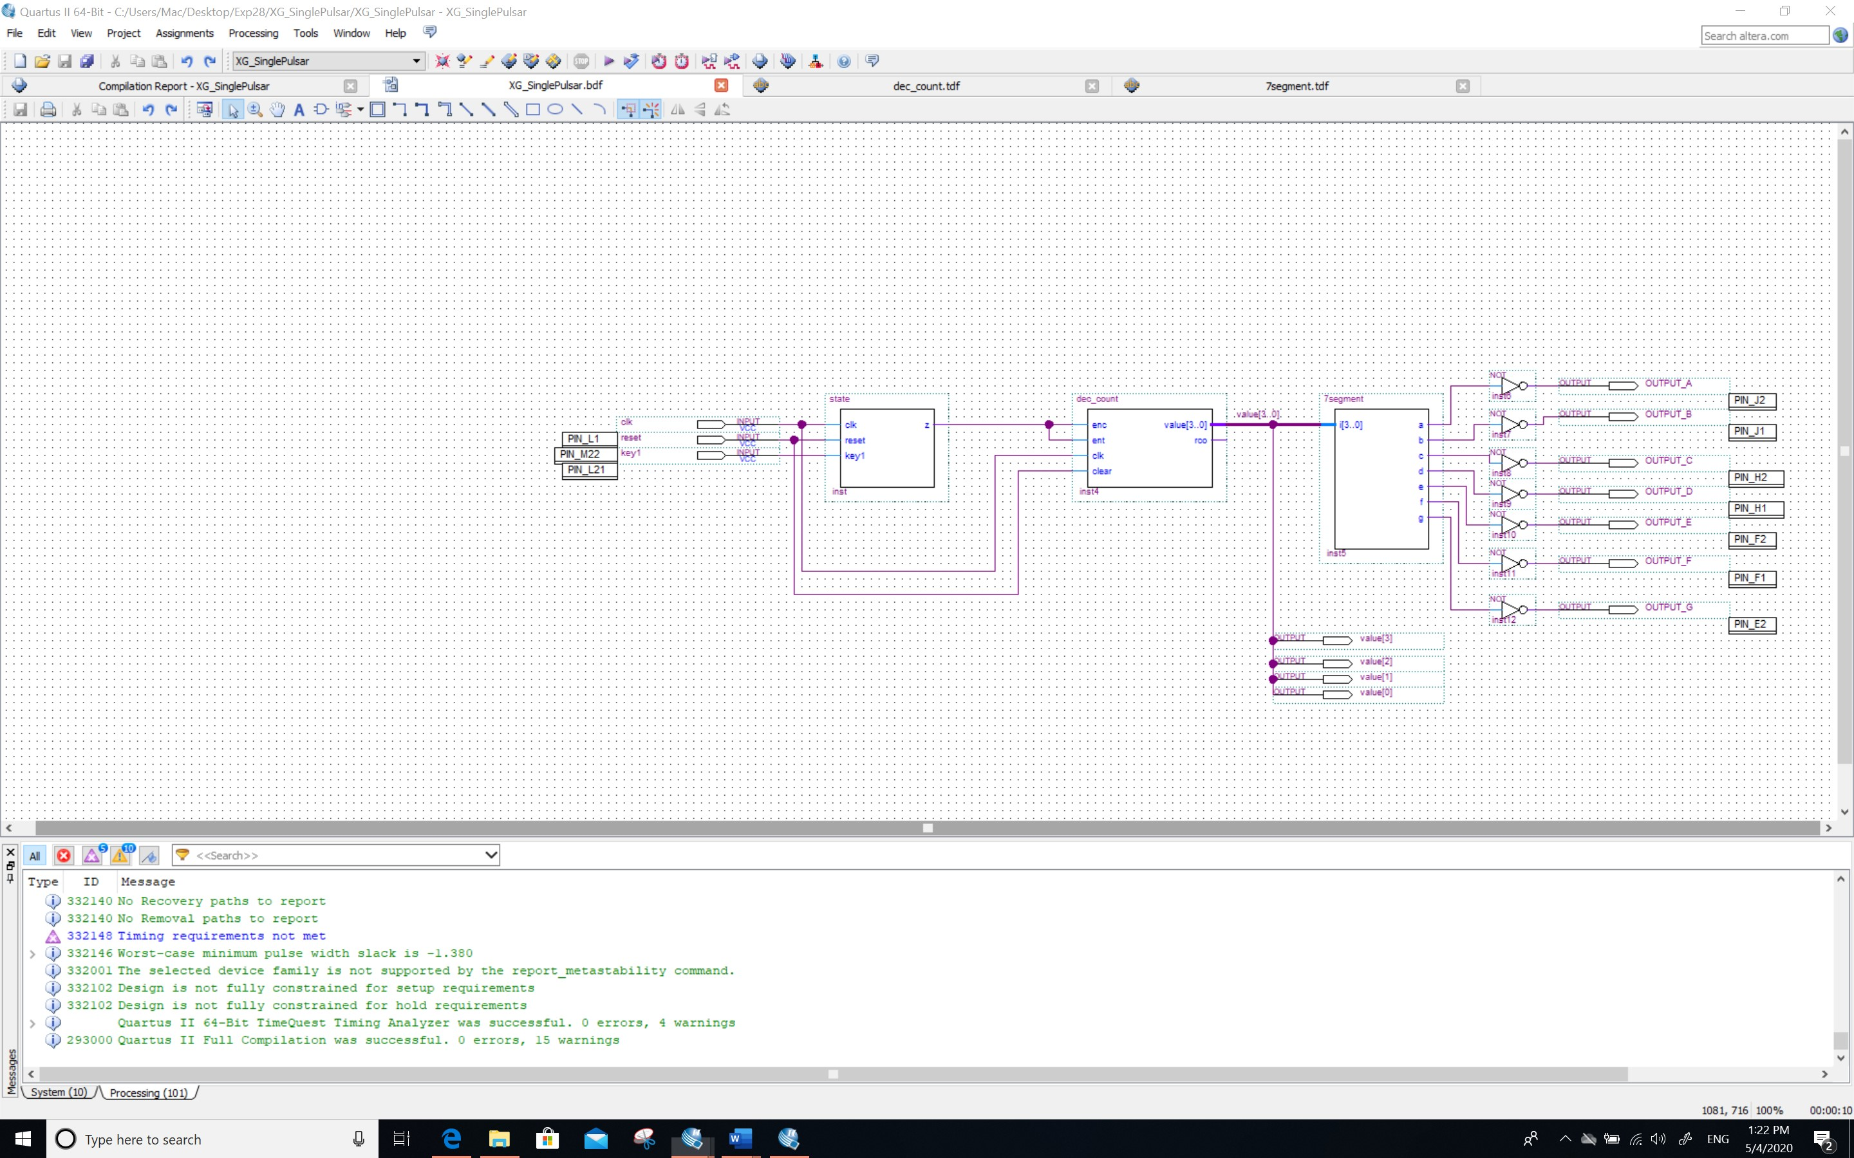

**Screenshots of the simulations:**

*Screenshots (PrintScreen or equivalent):*

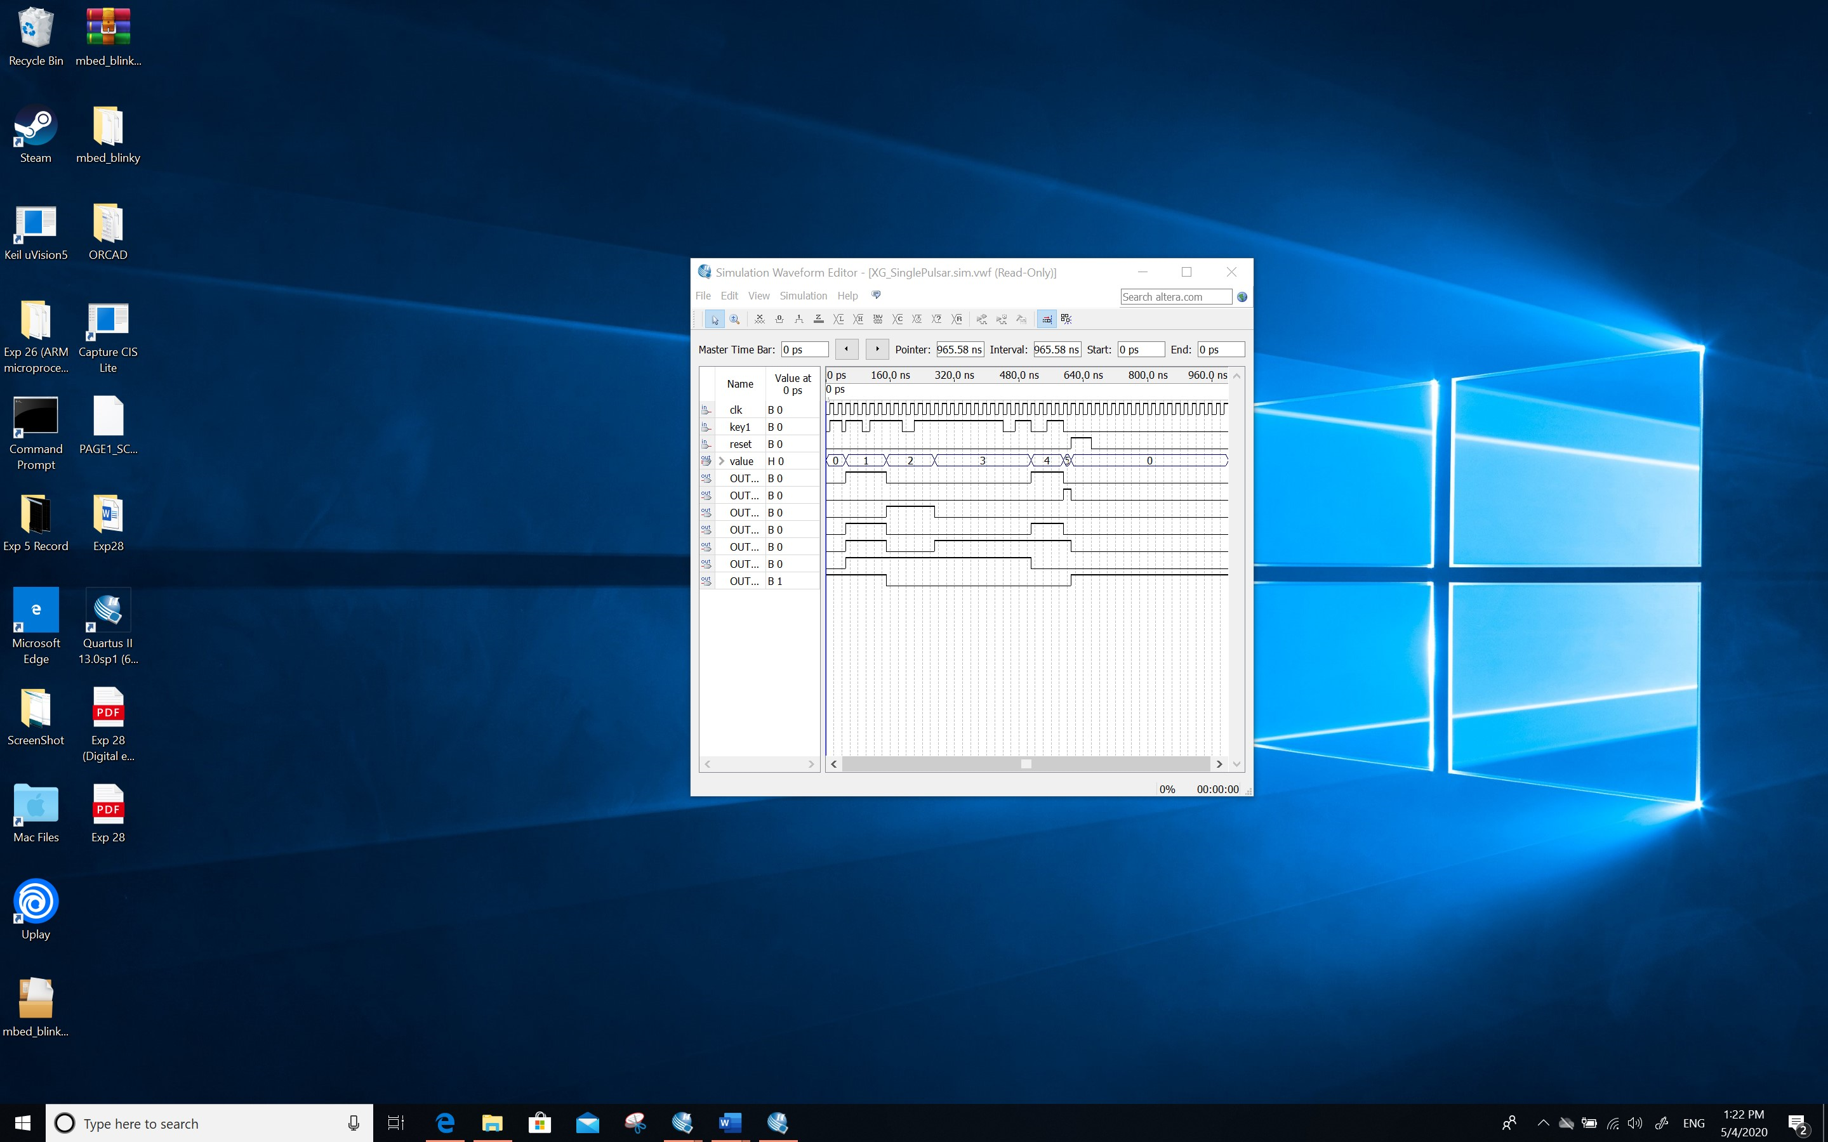

*Screenshots (Snipping tool or equivalent):*

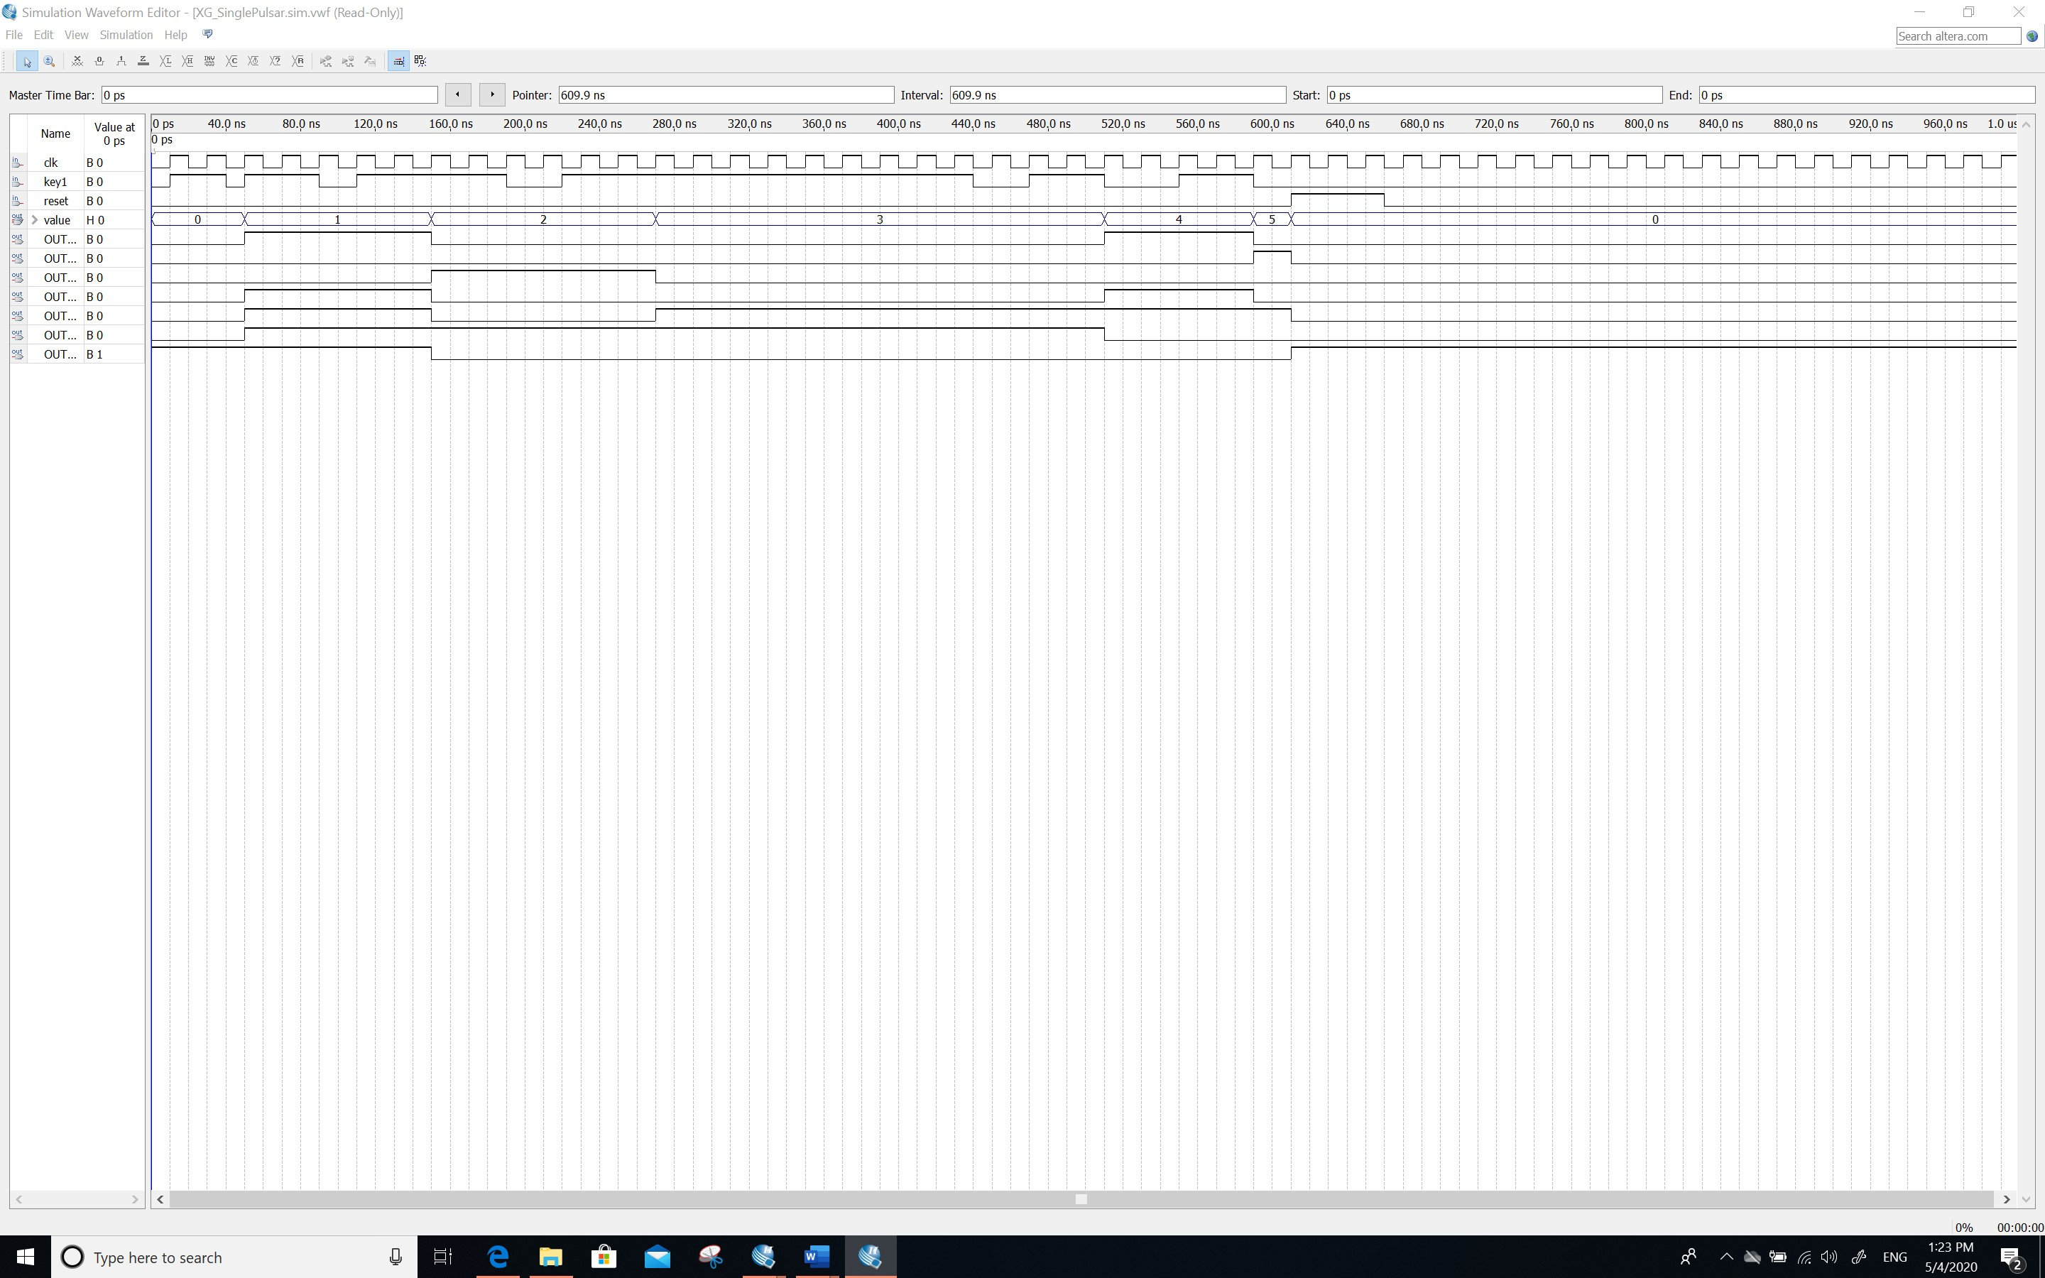

**Comment/Explanation:**

**This design combines a counter with a single pulsar, and the ultimate goal is to count the counter normally as long as the key press lasts longer than one clock cycle.** **In addition, due to the combination of CLR and reset, if the key is pressed, the counter returns to zero and key1 immediately reverts to S0 state.**

1. **The code, schematic design and annotated simulations of Section 4.3**

**[10 Marks]**

**The code (as text):**

**SUBDESIGN twos**

**(**

**sign, INPUT3, INPUT2, INPUT1 : INPUT; % two enables and the clock %**

**value[3..0] : OUTPUT; % Four output bits %**

**)**

**VARIABLE**

**count[3..0] :NODE;**

**BEGIN**

**count[0] = INPUT1;**

**count[1] = INPUT2;**

**count[2] = INPUT3;**

**count[3] = sign;**

**IF(sign) THEN**

**count[3..0] = 0 - count[3..0];**

**END IF;**

**value[3..0] = count[3..0];**

**END;**

**Screenshot of the schematic design:**

*Screenshot (PrintScreen or equivalent):*

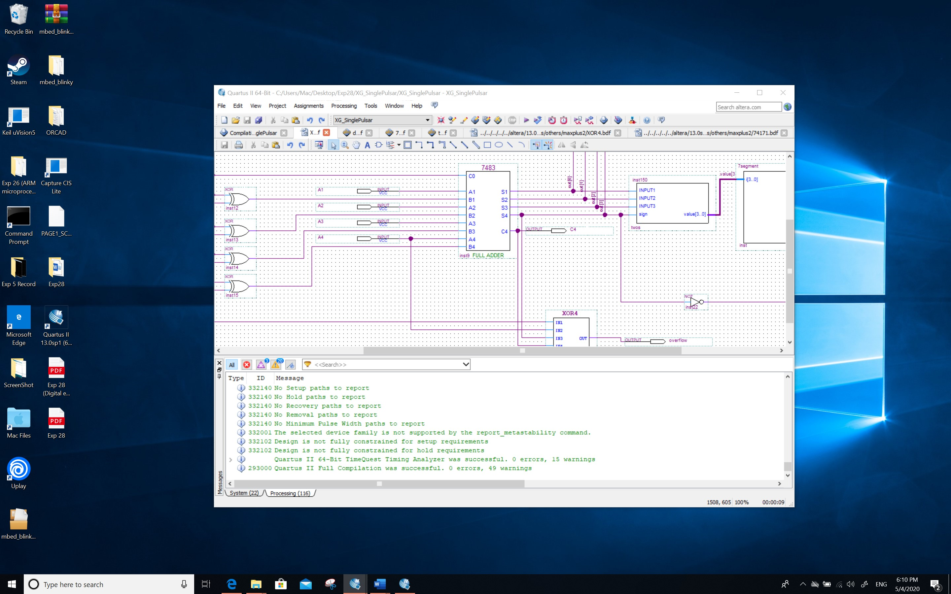

*Screenshot (Snipping tool or equivalent):*

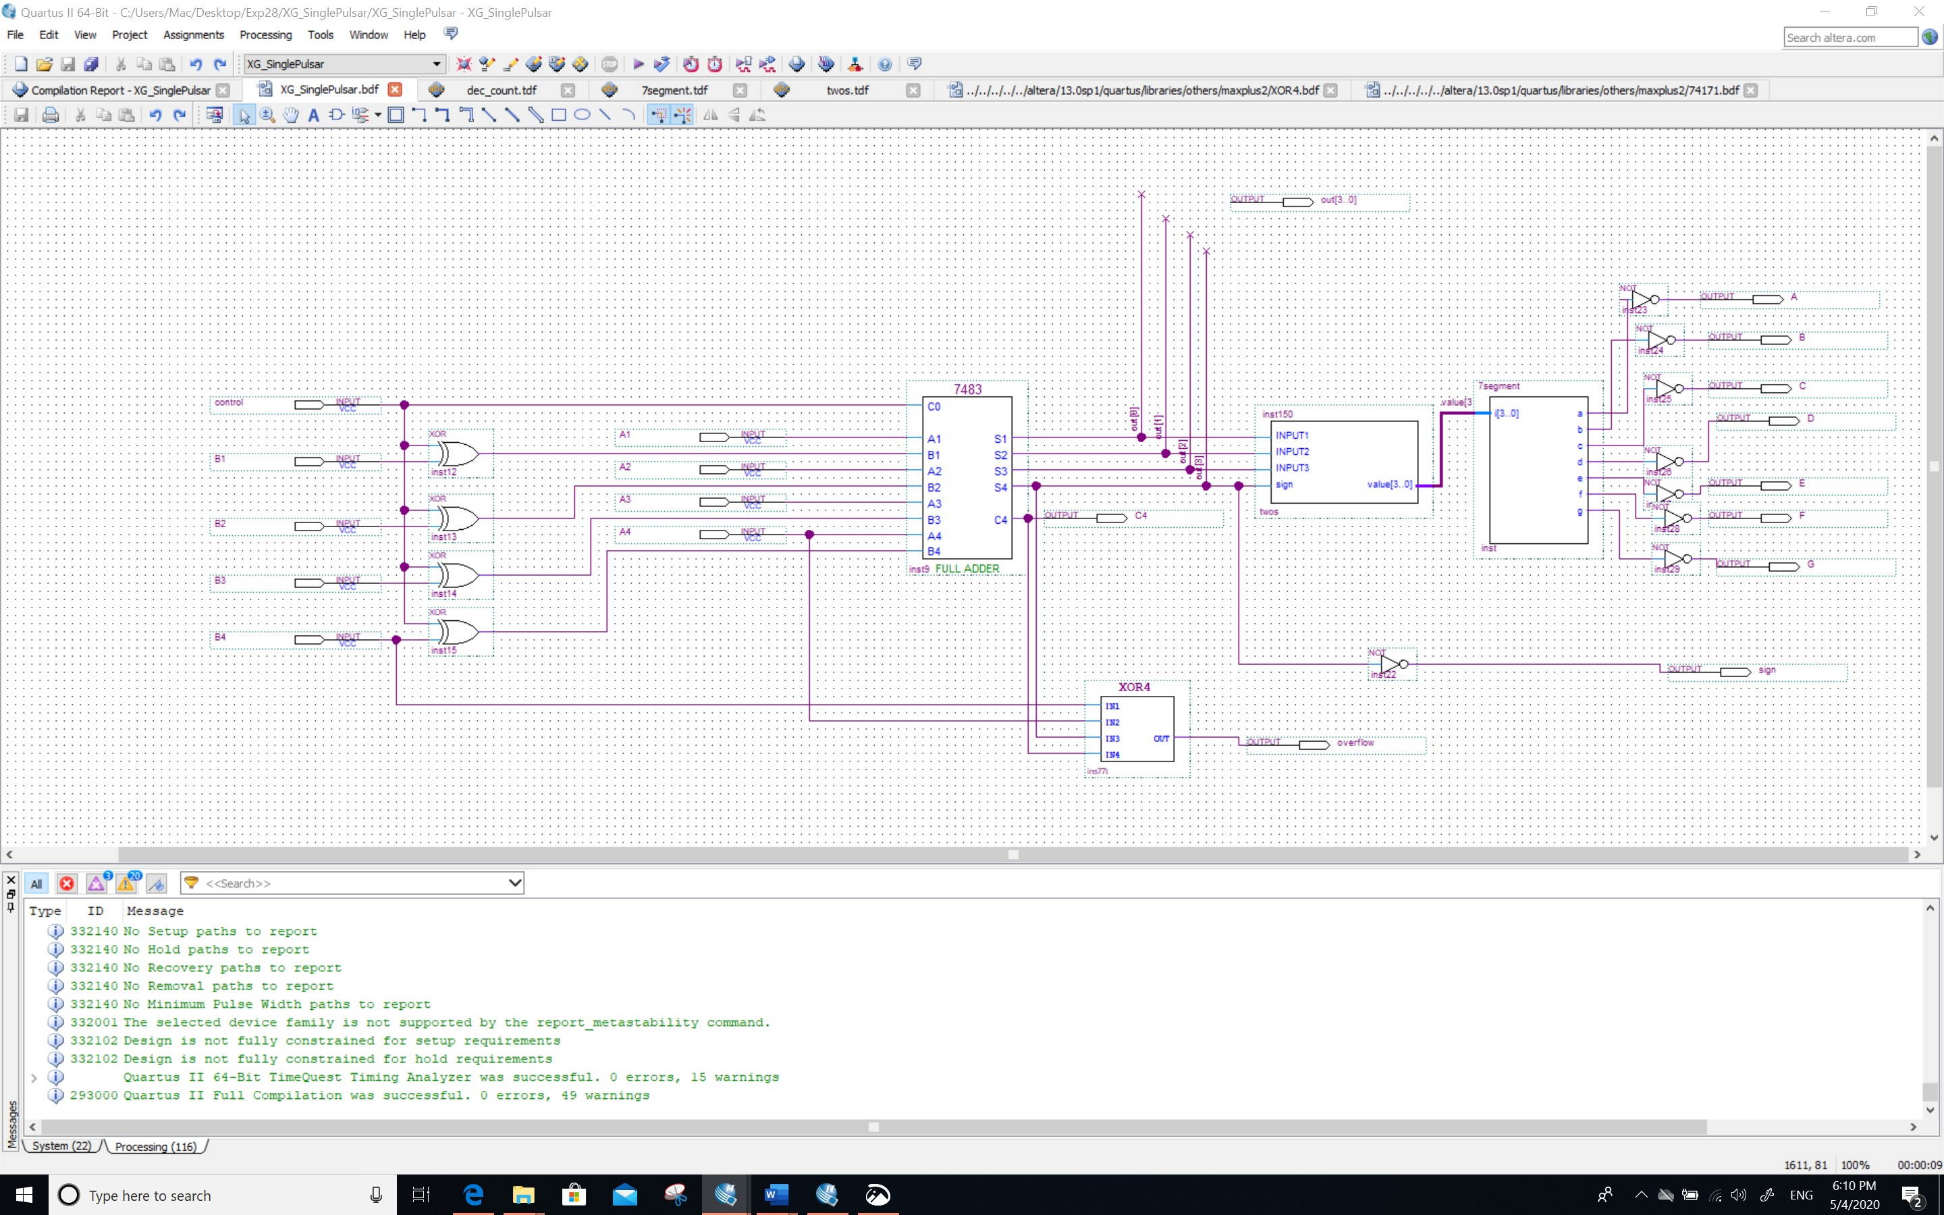

**Screenshot of the simulations:**

*Screenshot(s) (PrintScreen):*

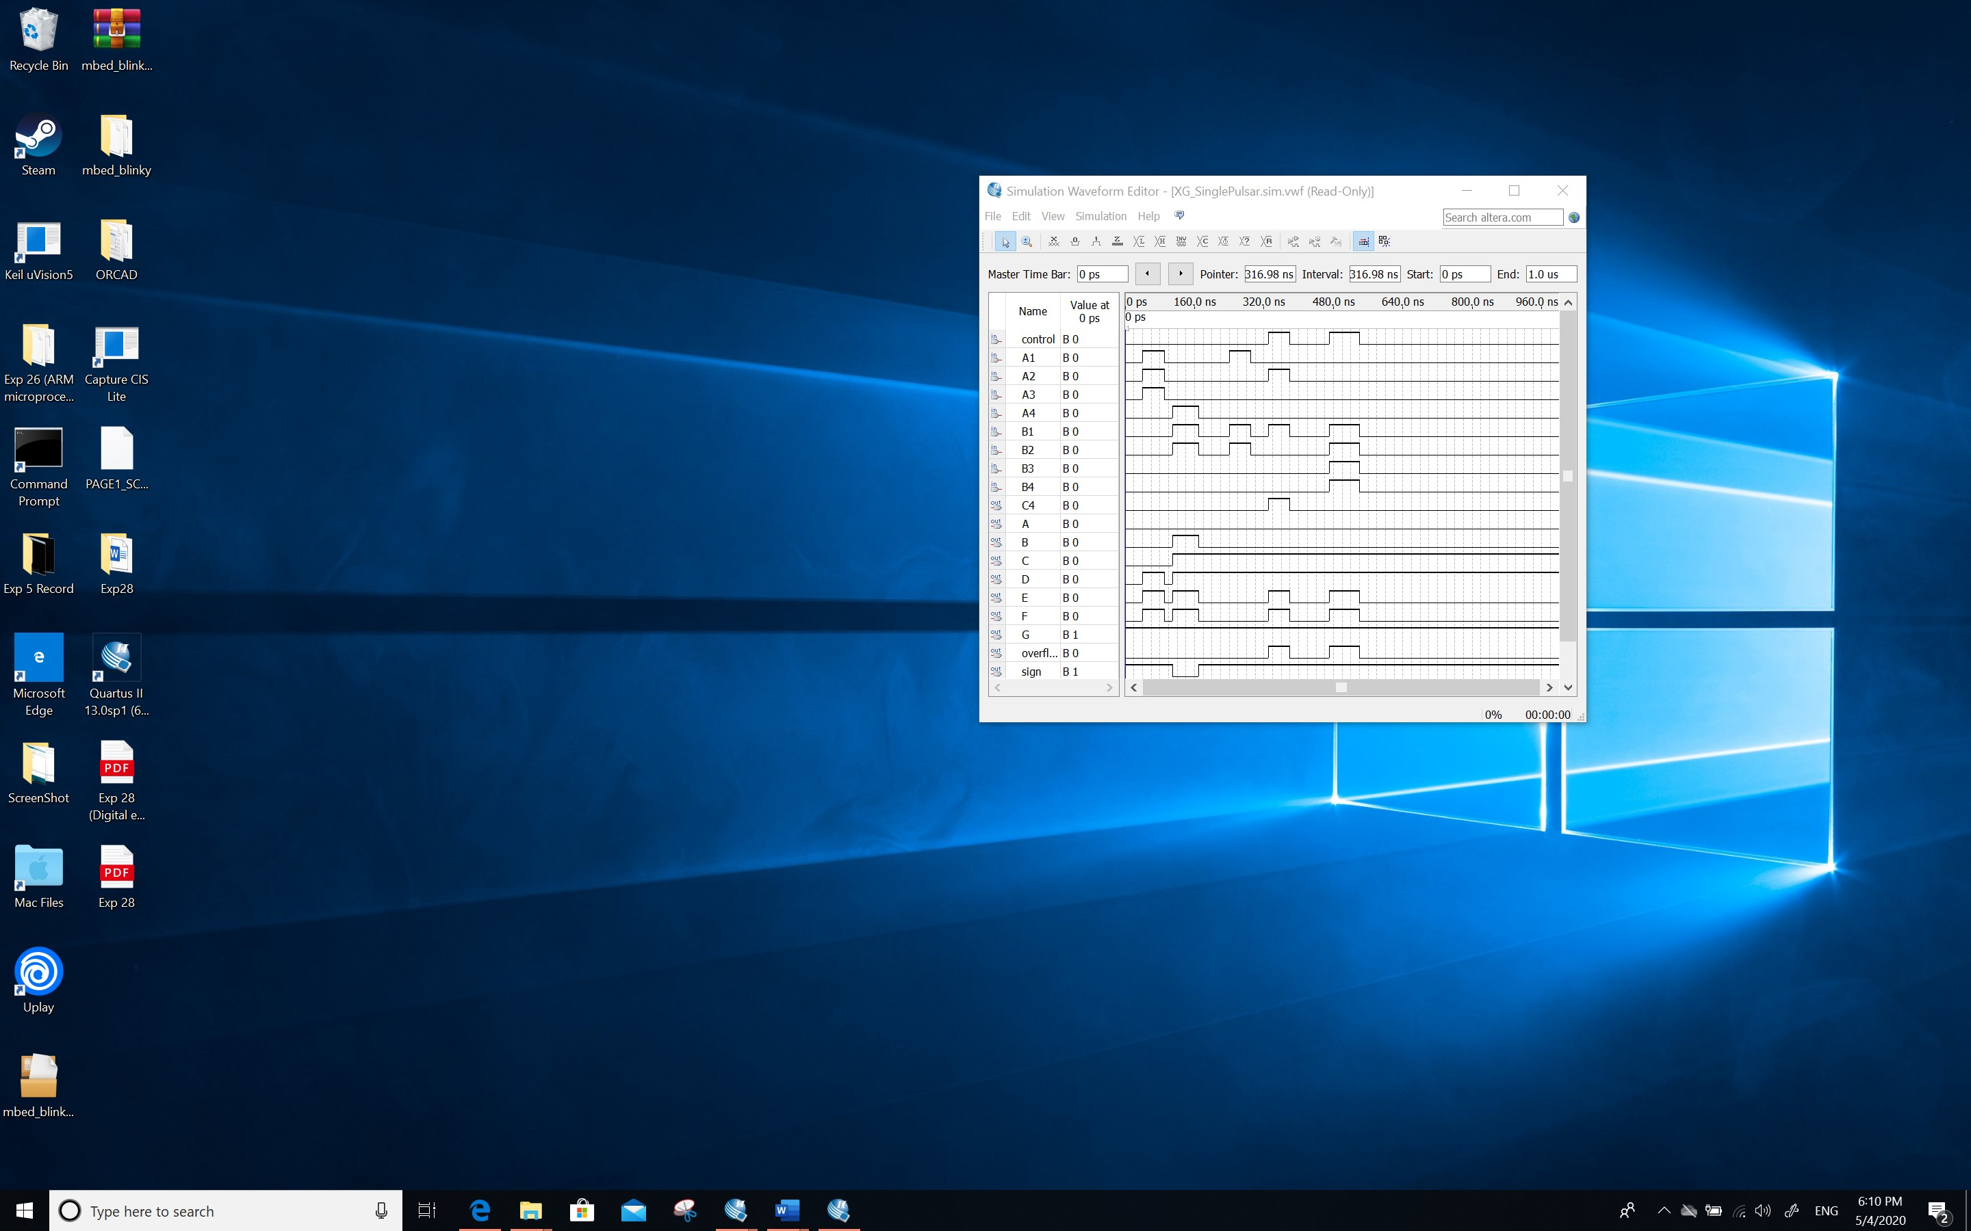

*Screenshot(s) (Snipping tool or equivalent):*

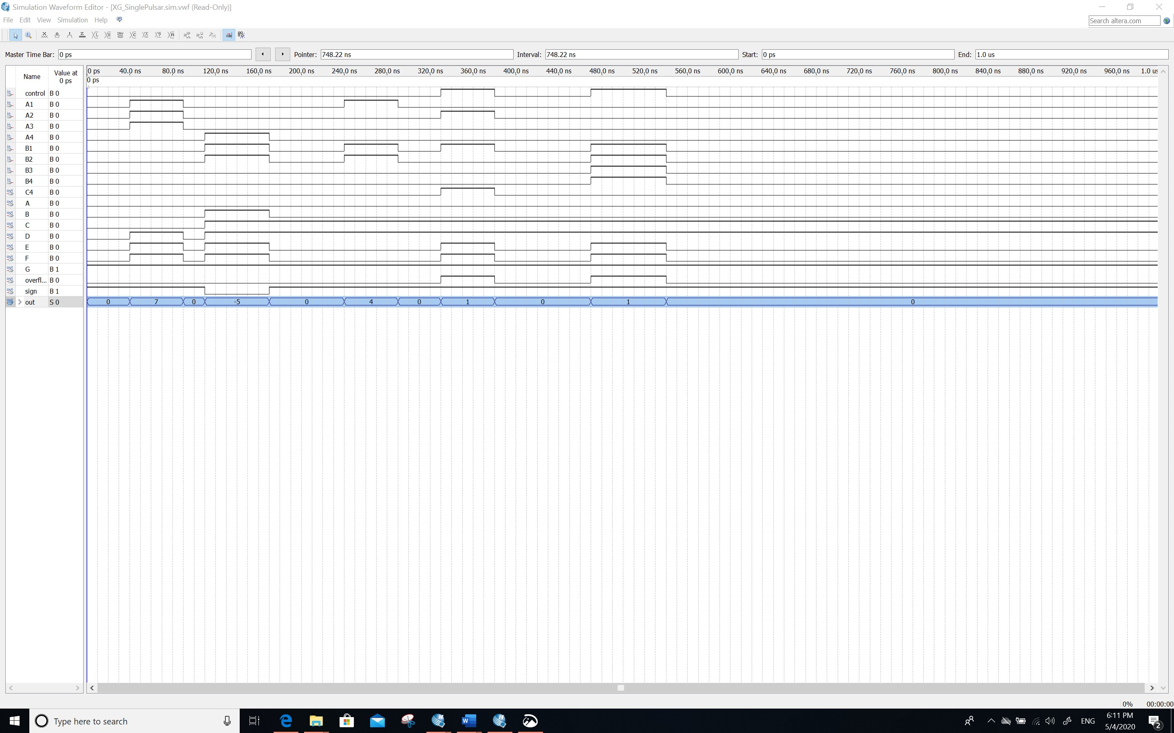

**Comment/Explanation:**

This design implements a four-digit arithmetic unit that can be added or subtracted, but clock synchronization is not implemented due to problems with the clock zeroing function of f-f in the simulator. However, for the subtractor, two's complement can be realized by using xor and carry, and then an f-f should be connected to use the clock. However, due to some problems, it is not realized. Next, programming component *two* is used, which is used to convert two's complement to display the diode of 7-segement. The final test that the design has been implemented.